

SOFTWARE REQUIREMENT SPECIFICATION
Wasabi Restaurant Management System(WRMS)

– Hanoi, May 2026–
Table of Contents
I. Record of Changes 5
II. Software Requirement Specification 6
1. Overall Requirements 6
1.1 Context Diagram 6
1.2 Main Business Processes 8
1.2.1 Dine-In Process (Quá trình khách đến ăn) 8
1.2.2 Online Table Booking (Quá trình đặt bàn online) 8
1.3 User Requirements 8
1.4 System Functionalities 18
1.5 Entity Relationship Diagram 21
1. Content Management Module (Website CMS) 21
2. User & Staff Module 22
3. Customer & Reservation Module 23
4. Table Management Module 24
5. Menu Management Module 25
6. Ordering Module (QR Order & Kitchen) 25
7. Payment, Promotion, & Tax Module (Payment, Promo, Tax) 26
8. System History Module (Notification Logs) 28
2. Use Case Specifications 29
2.1 Authentication & User Management 29
2.1.1 Login (AM-01) 29
2.1.2 Logout (AM-02) 30
2.1.3 Change Password (AM-03) 31
2.1.4 Change / Reset Password (AM-03) 31
2.1.5 Manage User Accounts (UM-01) 32
2.1.6 Assign Roles & Permissions (UM-02) 33
2.1.7 View Audit Log (UM-03) 34
2.1.7 Export / Import System Data (UM-04) 34
2.2 Reservation Management 35
2.2.1 Create Reservation (RM-01) 35
2.2.2 Modify Reservation (RM-02) 36
2.2.3 Cancel Reservation (RM-03) 36
2.2.4 Check-in Reservation (RM-04) 37
2.2.5 View Reservation Calendar (RM-05) 38
2.2.6 Monitor Reservations (Dashboard) (RM-06) 38
2.2.7 Seat Walk-in Guest (RM-07) 39
2.2.8 Handle No-show (RM-08) 40
2.3 Online Reservation 41
2.3.1 View Reservation Availability (ORM-01) 41
2.3.2 Submit Online Reservation (ORM-02) 41
2.3.3 Cancel Reservation (Online) (ORM-03) 42
2.3.4 Modify Online Reservation (ORM-04) 43
2.4.1 View Table Status (TM-01) 44
2.4.2 Update Table Status (TM-02) 44
2.4.3 Automatic Table Status Update (TM-03) 45
2.4.4 Transfer / Merge Tables (TM-04) 46
2.5 Guest Ordering 46
2.5.1 View Digital Menu (GO-01) 46
2.5.2 Modify Order Items (GO-02) 47
2.5.3 Submit Order Request (GO-03) 48
2.5.4 View Order Status (GO-04) 48
2.5.5 Request Assistance (GO-05) 49
2.6 Order Management 49
2.6.1 View Orders (OM-01) 49
2.6.2 Update Order (OM-02) 50
2.6.3 Add / Remove Dishes (OM-03) 51
2.6.4 Cancel Order (OM-04) 51
2.6.5 Update Cooking Status (OM-05) 52
2.6.6 Mark Order as Served (OM-06) 53
2.6.7 Respond to Assistance Request (OM-07) 53
2.7 Payment & Invoice Management 54
2.7.2 Apply Discount / Promotion (PM-02) 55
2.7.3 Process Payment (PM-03) 55
2.7.4 Close Order (PM-04) 56
2.7.5 Print / Send Invoice (PM-05) 57
2.7.6 View Invoice Details (PM-06) 57
2.7.7 View Payment History (PM-07) 58
2.7.8 Split / Merge Bill (PM-08) 58
2.7.9 Void / Refund Payment (PM-09) 59
2.7.10 Reopen Closed Order (PM-10) 60
2.7.11 Manage Promotions / Discounts (PM-11) 60
2.8 Shift Management 61
2.8.1 Open Shift (SM-01) 61
2.8.2 Record Cash In / Out (SM-02) 62
2.8.3 Close Shift (SM-03) 62
2.8.4 View Shift Summary (SM-04) 63
2.9 Menu Management 64
2.9.1 Create / Update Menu Item (MM-01) 64
2.9.2 Manage Categories (MM-02) 64
2.9.3 Search / Filter Menu Items (MM-03) 65
2.9.4 Import / Export Menu Data (MM-04) 65
2.10 Report & Analytics 66
2.10.1 View Financial Reports (RA-01) 66
2.10.2 View Guest Traffic Analysis (RA-02) 67
2.10.3 View Menu Performance Report (RA-03) 67
2.11 Notification Management 68
2.11.1 Send Reservation Notification (NM-01) 68
2.11.2 Send Payment Notification (NM-02) 69
2.11.3 Manage Notification Log (NM-03) 69
2.11.4 Send Manual Notification (NM-04) 70
3. Functional Requirements 72
3.1 Feature Name1 72
3.2 User Authentication 72
3.3 System Administration 73
4. Non-Functional Requirements 74
4.1 External Interfaces 74
4.1.1 User Interfaces 75
4.1.2 Hardware Interfaces 75
4.1.3 Software Interfaces 75
4.1.4 Communication Interfaces 76
4.2 Quality Attributes 76
4.2.1 Usability 76
4.2.2 Performance 76
4.2.3 Security 77
4.2.4 Reliability & Availability 78
4.2.5 Scalability & Capacity 78
4.2.6 Maintainability 78
4.2.7 Compatibility & Portability 79
4.2.8 Compliance & Legal (Vietnam) 79
5. Requirement Appendix 79
5.1 Business Rules 79
5.2 System Messages 80
5.3 Other Requirements… 80

I. Record of Changes
Date | A*  M, D | In charge | Change Description
16/05 | A | Nguyễn Quang Huy | 1.5 Entity Relationship Diagram
17/05 | A | Trần Duy Tấn | 1.1 Context Diagram
17/05 | A | Phạm Mạnh Tùng | Phạm Mạnh Tùng
18/05 | A | Phạm Mạnh Tùng | 1.2 Main Business Processes
18/05 | A | Trần Duy Tấn | 1.3 User Requirements
19/05 | M | Phạm Mạnh Tùng | 1.4 System Functionalities
22/5 | M | Nguyễn Quang Huy | 1.5 Entity Relationship Diagram
23/5 | A | Nguyễn Quang Huy,Phan Mai Chi, Trần Duy Tấn | 2. Use Case Specification
25/5 | M | Nguyễn Quang Huy | 2. Use Case Specification
27/5 | M | Phạm Mạnh Tùng | Phạm Mạnh Tùng
28/5 | M | Trần Duy Tấn | 1.3 User Requirements
30/5 | A | Nguyễn Đức Lâm | 4. Non-Functional Requirements
31/5 | A | Phan Mai Chi | 5. Requirement Appendix
*A - Added M - Modified D - Deleted

II. Software Requirement Specification

1. Overall Requirements

1.1 Context Diagram
The Restaurant Management System is a comprehensive software solution designed to digitize and streamline daily restaurant operations, replacing traditional manual processes for table reservations, order taking, shift management, and billing.
The context diagram below illustrates the system boundary and its direct interfaces with all external entities. It identifies the key human components interacting with the system (Administrator, Restaurant Manager, Waiter, Cashier, and Guest) as well as external third-party systems (Payment Gateway and Email/SMS Service). The diagram clearly outlines the vital data flows—such as online reservation requests, payment authorizations, management reports, and automated notifications—moving between these external terminators and the core system.

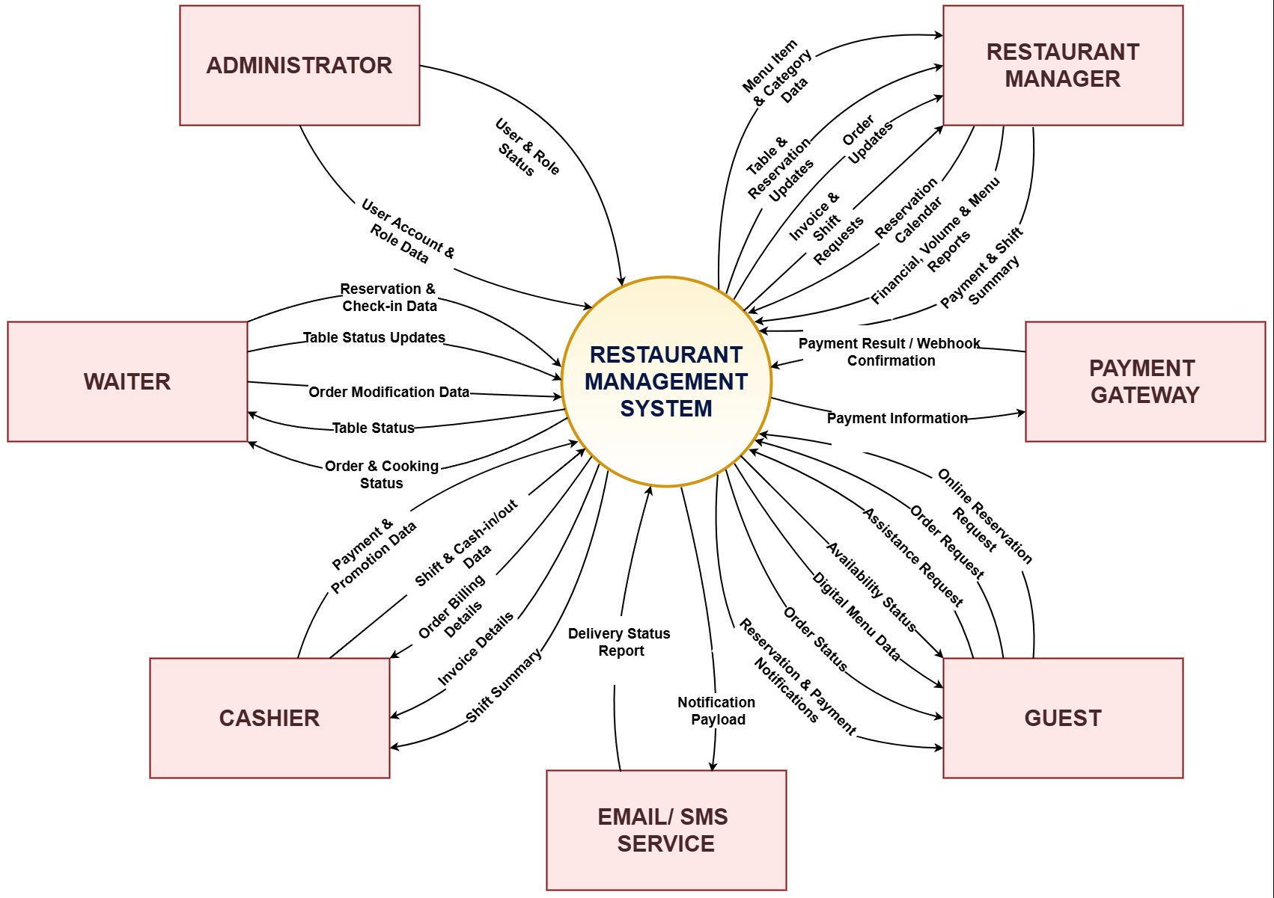

1.2 Main Business Processes

1.2.1 Dine-In Process (Quá trình khách đến ăn)
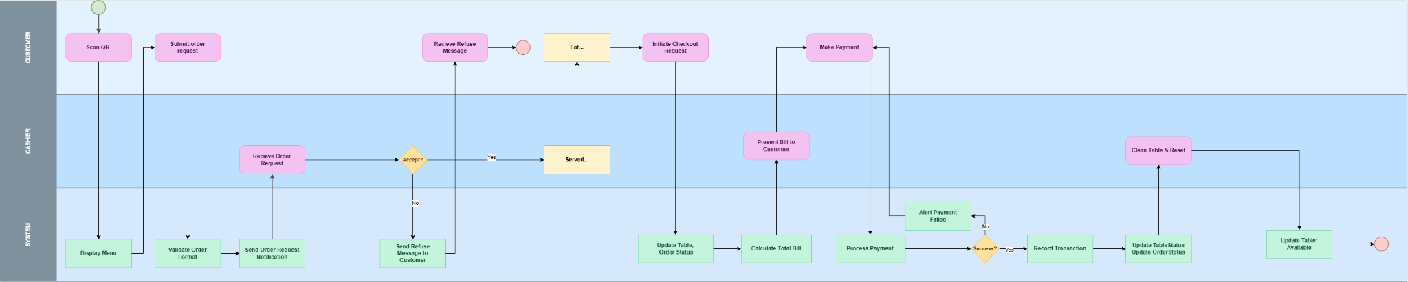

1.2.2 Online Table Booking (Quá trình đặt bàn online)
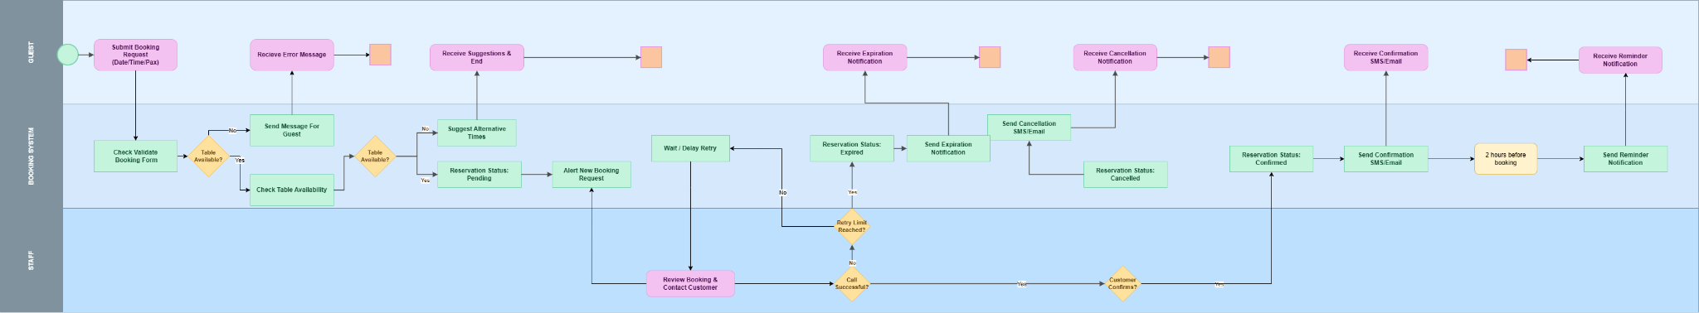

1.3 User Requirements

1.3.1 Actors

ID | Actor | Description
AC-01 | Guest / Customer | External user of the online reservation website and digital ordering. Makes and cancels reservations, browses the menu, submits orders, tracks status, and requests assistance. No account/login required.
AC-02 | Waiter | Internal staff serving customers. Manages reservations and table status, checks in guests, seats walk-ins, creates/updates orders, tracks cooking, and serves food.
AC-03 | Cashier | Internal staff handling billing and payment. Generates invoices, applies discounts, processes payments, splits/merges bills, and manages shifts (open/close, cash in/out).
AC-04 | Manager | Oversees operations. Monitors reservations, manages menu, promotions and notifications, views reports/analytics, shift summaries, and payment history.
AC-05 | System Administrator | Manages system configuration and access. Maintains user accounts, roles and permissions, audit log, and data export/import.
AC-06 | System | Non-human/automated actor. Triggers automatic table status updates and sends automated reservation/payment notifications.
AC-07 | Payment gateway | External service that processes online payments and sends payment result/webhook confirmations back to the system.
AC-08 | Email/SMS Service | External service that sends automated reservation, payment, and order-status notifications on behalf of the system.

1.3.2 Use Cases (UC)

ID | Use Case | Feature (Module) | Actor | Use Case Description
AM-01 | Login | Authentication & User Mgmt | All Staff (AC-02→AC-06) | Authenticate with credentials to access the POS system.
AM-02 | Logout | Authentication & User Mgmt | All Staff (AC-02→AC-06) | End the current session securely.
AM-03 | Change Password | Authentication & User Mgmt | All Staff (AC-02→AC-06) | Allow users to change passwords.
AM-04 | Forgot Password | Authentication & User Mgmt | All Staff (AC-02→AC-06) | Recover a forgotten password.
UM-01 | Manage User Accounts | Authentication & User Mgmt | All Staff (AC-02→AC-06) | Create, update, deactivate, or delete staff accounts.
UM-02 | Register | Authentication & User Mgmt | System Administrator | Allow a new user to create an account in the system.
UM-03 | View Audit Log | Authentication & User Mgmt | System Administrator, Manager | View the log of important system activities (logins, payments, voids, config changes). Satisfies the audit-logging NFR.
UM-04 | Export / Import System Data | Authentication & User Mgmt | System Administrator | Bulk export or import core data (general admin data feature, beyond menu only).
RM-01 | Create Reservation | Reservation Mgmt | Waiter | Create a reservation manually on behalf of a guest.
RM-02 | Modify Reservation | Reservation Mgmt | Waiter | Edit details (time, party size, table) of an existing reservation.
RM-03 | Cancel Reservation | Reservation Mgmt | Waiter | Cancel a reservation and free the associated table.
RM-04 | Check-in Reservation | Reservation Mgmt | Waiter | Mark a reserved guest as arrived and seat them.
RM-05 | View Reservation Calendar | Reservation Mgmt | Waiter, Manager | View reservations on a calendar/timeline view.
RM-06 | Monitor Reservations (Dashboard) | Reservation Mgmt | Manager | Summary/dashboard view of reservation load and status (distinct from calendar).
RM-07 X | Seat Walk-in Guest | Reservation Mgmt | Waiter | Seat a guest with no reservation, assign a table, and open an order session.
RM-08  To RM-02 | Handle No-show | Reservation Mgmt | Waiter, Manager | Mark a reservation as no-show and release the held table.
ORM-01 | View Reservation Availability | Online Reservation | Guest | Check available tables/time slots online.
ORM-02 | Submit Online Reservation | Online Reservation | Guest | Submit a reservation request through the website.
ORM-03 X | Cancel Reservation (Online) | Online Reservation | Guest | Cancel a previously submitted online reservation.
ORM-04 X | Modify Online Reservation | Online Reservation | Guest | Edit a submitted online reservation (resolves the “modify or cancel” statement in the System Overview).
TM-01 | View Table Status | Table Mgmt | Waiter/Cashier | View real-time occupancy/availability of tables.
TM-02 | Update Table Status | Table Mgmt | Waiter/Cashier | Manually set a table as free, occupied, or reserved.
TM-03 | Automatic Table Status Update | Table Mgmt | System | Auto-update table status from check-in, order, or payment events.
TM-04 | Transfer / Merge Tables | Table Mgmt | Waiter | Move a party to another table or merge tables, carrying the order/state along.
GO-01 | View Digital Menu | Guest Ordering | Offline Guest | Browse the digital menu and item details.
GO-02 | Modify Order Items | Guest Ordering | Offline Guest | Add, remove, or adjust items before submitting.
GO-03 | Submit Order Request | Guest Ordering | Offline Guest | Send the order request to the restaurant.
GO-04 | View Order Status | Guest Ordering | Offline Guest | Track the progress/status of a submitted order.
GO-05 | Request Assistance | Guest Ordering | Offline Guest | Send a service/assistance request to staff.
OM-01 | View Orders | Order Mgmt | Cashier | View active orders and their items.
OM-02 | Update Order | Order Mgmt | Cashier | Confirm or modify an order's details.
OM-03 | Add / Remove Dishes | Order Mgmt | Cashier | Add or remove dishes from an existing order.
OM-04 | Cancel Order | Order Mgmt | Cashier | Cancel an order or specific items.
OM-05  To OM-02 | Update Cooking Status | Order Mgmt | Cashier | Update preparation/cooking progress per dish/order.
OM-06  To OM-02 | Mark Order as Served | Order Mgmt | Cashier | Mark dishes/order as served, closing the serving step of the ordering flow.
OM-07 | Respond to Assistance Request | Order Mgmt | Cashier | Receive and resolve a guest assistance request (staff side of GO-05).
PM-01 | Generate Invoice | Payment & Invoice | Cashier | Create an invoice for an order. The system calculates the total by summing order line items, applying any service charge and applicable VAT, and subtracting discounts to produce the payable amount.
PM-02 | Apply Discount / Promotion | Payment & Invoice | Cashier | Apply eligible discounts or promotions to the bill (recalculates the total).
PM-03 | Process Payment | Payment & Invoice | Cashier | Process the customer's payment.
PM-04 | Close Order | Payment & Invoice | Cashier | Allow the cashier to finalize customer payment and request the system to close the order.
PM-05 | Print / Send Invoice | Payment & Invoice | Cashier | Print or electronically send the invoice.
PM-06 | View Invoice Details | Payment & Invoice | Cashier, Manager | View details of a specific invoice.
PM-07 | View Payment History | Payment & Invoice | Cashier, Manager | Review historical payment records.
PM-08 | Split / Merge Bill | Payment & Invoice | Cashier | Split one order into multiple checks or merge multiple checks into one (recalculates per-check totals).
PM-09 | Reopen Closed Order | Payment & Invoice | Cashier, Manager | Reopen a closed/paid order to correct items or payment.
PM-10 | Manage Promotions / Discounts | Payment & Invoice | Manager | Create and configure the promotions/discounts that PM-02 applies.
SM-01 | Open Shift | Shift Mgmt | Cashier | Open a cashier shift with opening balance.
SM-02 | Record Cash In / Out | Shift Mgmt | Cashier | Record cash movements during the shift.
SM-03 | Close Shift | Shift Mgmt | Cashier | Close the shift and reconcile totals.
SM-04 | View Shift Summary | Shift Mgmt | Cashier, Manager | View summary/report of a shift.
MM-01 | Create / Update Menu Item | Menu Mgmt | Manager | Add or edit menu items (price, name, availability).
MM-02 | Manage Categories | Menu Mgmt | Manager | Create and organize menu categories.
MM-03 | Search / Filter Menu Items | Menu Mgmt | Manager | Search and filter items in the menu catalog.
MM-04 | Import / Export Menu Data | Menu Mgmt | Manager | Bulk import or export menu data.
RA-01 | View Financial Reports | Report & Analytics | Manager | View revenue and financial performance reports.
RA-02 | View Guest Traffic Analysis | Report & Analytics | Manager | Analyze guest traffic and reservation trends.
RA-03 | View Menu Performance Report | Report & Analytics | Manager | Review best/worst-performing menu items.
NM-01 | Send Reservation Notification | Notification Mgmt | System | Auto-send reservation confirmations/reminders to guests.
NM-02 | Send Payment Notification | Notification Mgmt | System | Auto-send payment confirmation to the guest.
NM-03 | Manage Notification Log | Notification Mgmt | Manager | View and manage the notification history/log.
NM-04 | Send Manual Notification | Notification Mgmt | Manager | Manually compose and send a notification (resolves the “manual notifications” feature text).
1.3.2 Use Case Diagrams

1.3.2.1 UCs for Guest/Customer
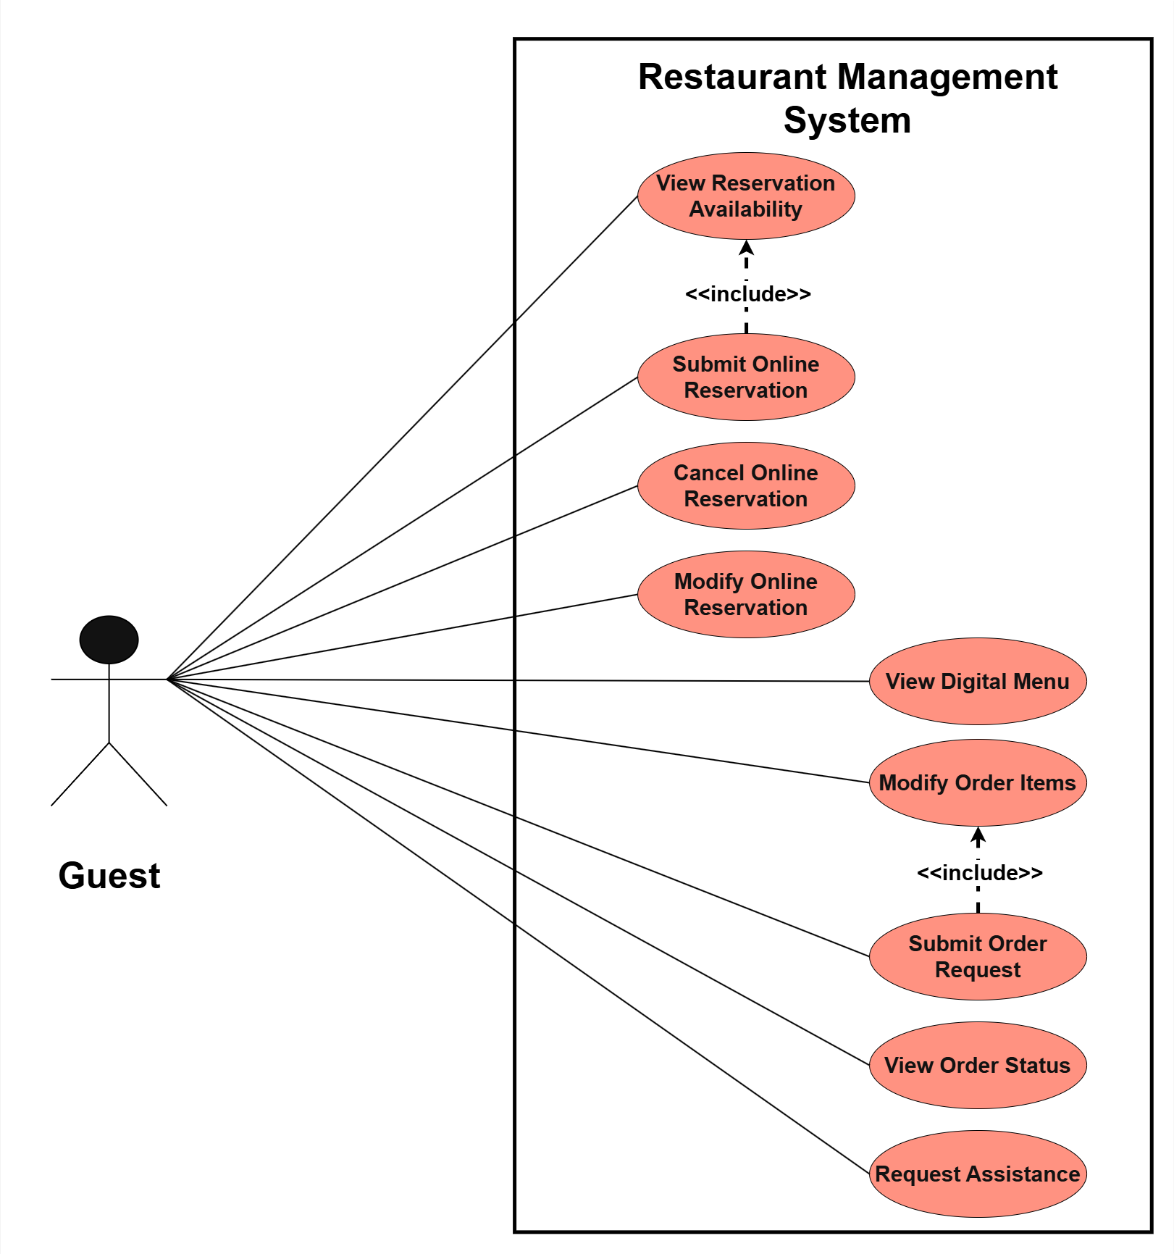

1.3.2.2 UCs for Waiter
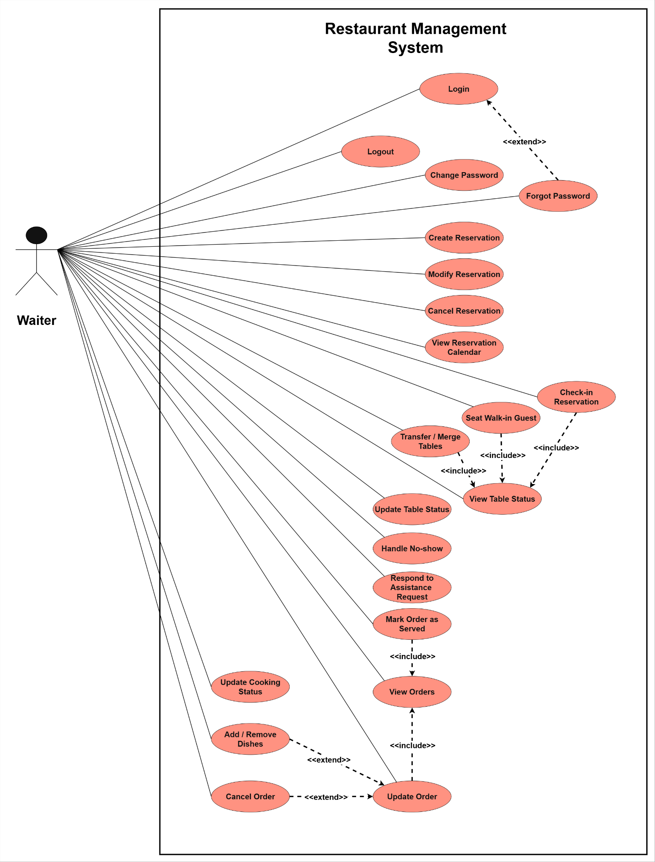

1.3.2.3 UCs for Cashier
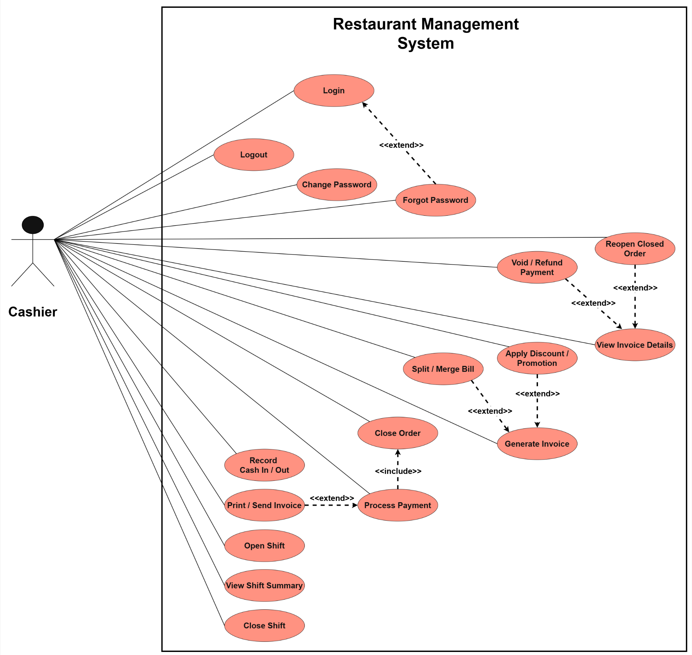

1.3.2.4 UCs for Manager
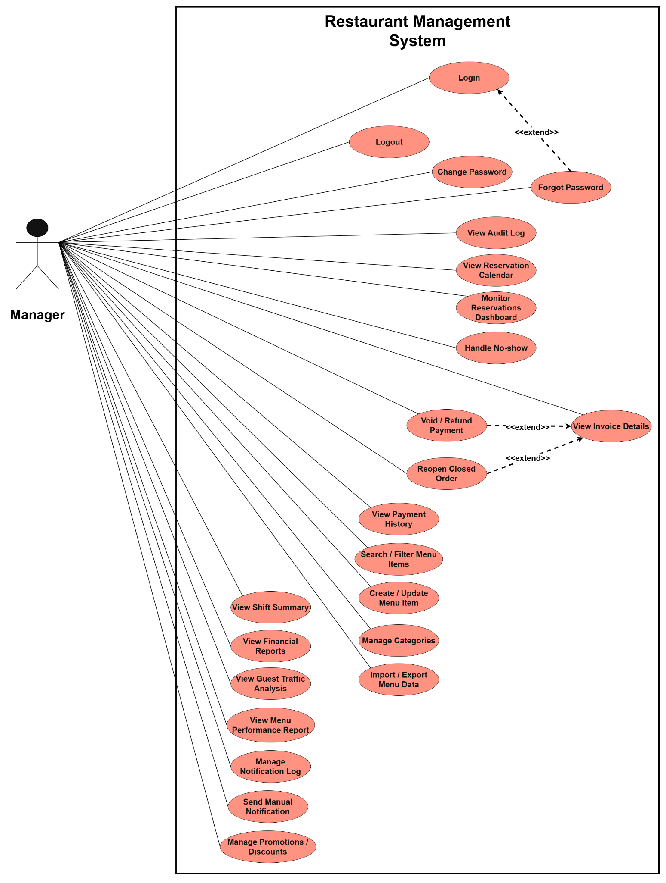

1.3.2.5 UCs for System Administrator
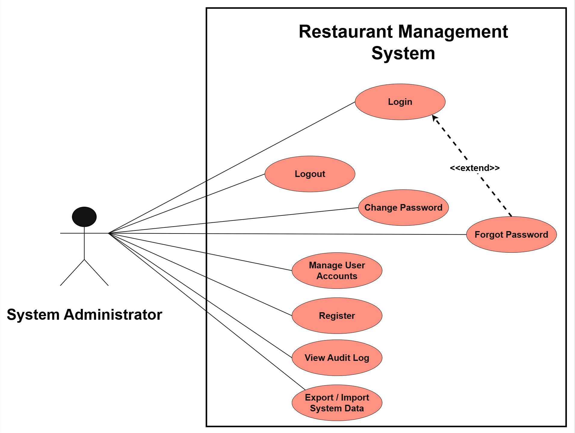

1.3.2.6 UCs for System
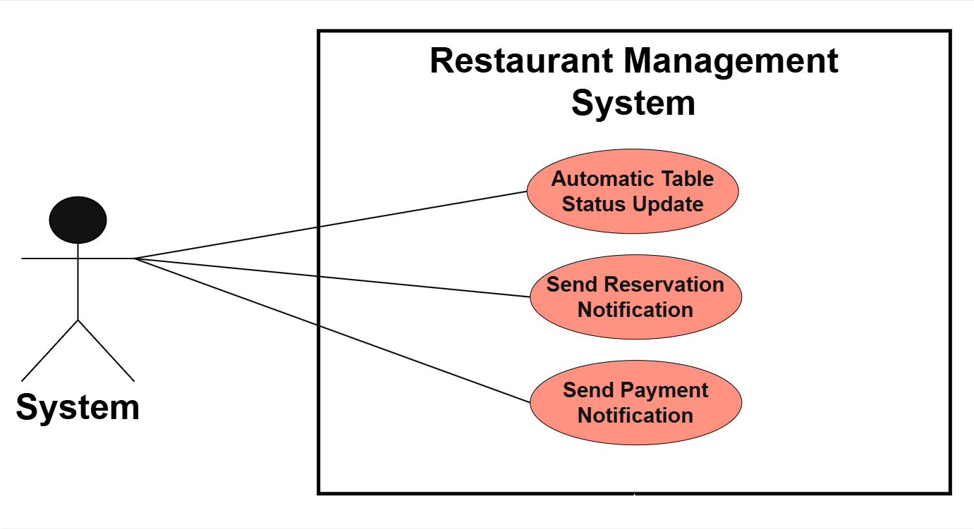

1.4 System Functionalities

1.4.1 Screens Flow
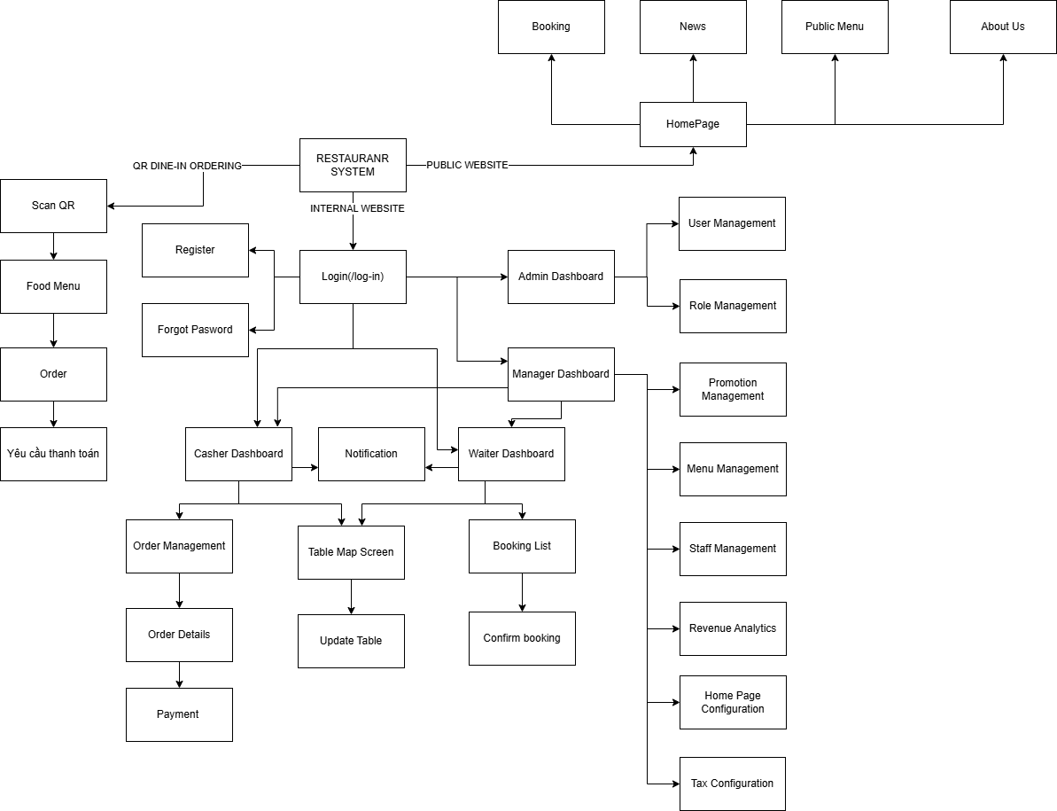

1.4.2 Screen Authorization

Screen | Online Guest | Customer (QR Dine-in) | Admin | Cashier | Waiter
HomePage | X | X | X | X | X
Booking (Public) | X | X | X | X | X
News | X | X | X | X | X
Public Menu | X | X | X | X | X
About Us | X | X | X | X | X
Scan QR |  | X
Food Menu |  | X
Giỏ hàng (Cart) |  | X
Đặt hàng (Place Order) |  | X
Yêu cầu thanh toán |  | X
Login |  |  | X | X | X
Admin Dashboard |  |  | X
Menu Management |  |  | X
Menu Update |  |  | X
Staff Management |  |  | X
Staff Update |  |  | X
Home Page Management |  |  | X
Home Page Configuration |  |  | X
Revenue Analytics |  |  | X
Staff Dashboard |  |  | X | X | X
Notification |  |  | X | X | X
Order Management |  |  | X | X
Order Details |  |  | X | X
Thanh Toán (Payment) |  |  | X | X
Export Bill |  |  | X | X
Table Map Screen |  |  | X | X | X
Update Table |  |  | X | X | X
Booking List |  |  | X | X | X
Confirm Booking |  |  | X | X | X

1.4.3 Non-UI Functions
[Provide the descriptions for the non-screen system functions, i.e batch/cron job, service, API, etc.]

Feature | System Function | Description
Notification | Omnichannel Notification Worker | [Event Consumer] Consumes messaging queues to format and dispatch asynchronous SMS, Email, and Push notifications. (Trigger: NotificationRequestedEvent)
Notification | WebSocket Broadcaster Service | [Background Service] Maintains persistent WebSocket connections to push real-time state changes to client devices, KDS, and Admin dashboards.
Table & Booking | No-Show Auto-Release Job | [Cron Job] Periodically queries reservations and automatically releases tables if customers fail to check-in within the grace period.
Table & Booking | Booking Reminder Scheduler | [Scheduler] Scans upcoming reservations and dispatches reminder payloads to the Notification queue prior to the booking time.
Payment | Payment Webhook Listener | [Webhook] API endpoint designed to ingest async payment status callbacks from VNPay, Momo, or Stripe. Validates signature and updates orders.
Payment | Payment Status Reconciliation | [Batch Job] Reconciles local transaction records against payment gateway APIs to identify and resolve stuck or dropped transactions.
Order Management | Order Expiration Worker | [Queue Worker] Monitors unconfirmed QR dine-in orders and automatically cancels them using Redis TTL or a Delayed Message Queue.
Order Management | Kitchen Ticket Dispatcher | [Event Consumer] Listens for order confirmation events and routes structured order payloads to the respective kitchen stations.
Revenue Analytics | EOD Revenue Aggregation | [Batch Job] Extracts, transforms, and loads (ETL) daily transactional data (sales, discounts) into optimized OLAP/Analytics tables.
Revenue Analytics | Real-Time Metrics Streamer | [Stream Processor] Continuously calculates rolling metrics (e.g., current active diners, live hourly revenue) and caches aggregates in Redis.
System & Security | Audit Log Processor | [Event Consumer] Asynchronously writes detailed security and compliance audit logs (login attempts, critical mutations) to Elasticsearch.
System & Security | Data Archival & Cleanup | [Batch Job] Archives historical data (e.g., old orders) to cold storage and purges expired JWT tokens and cache entries.

1.5 Entity Relationship Diagram
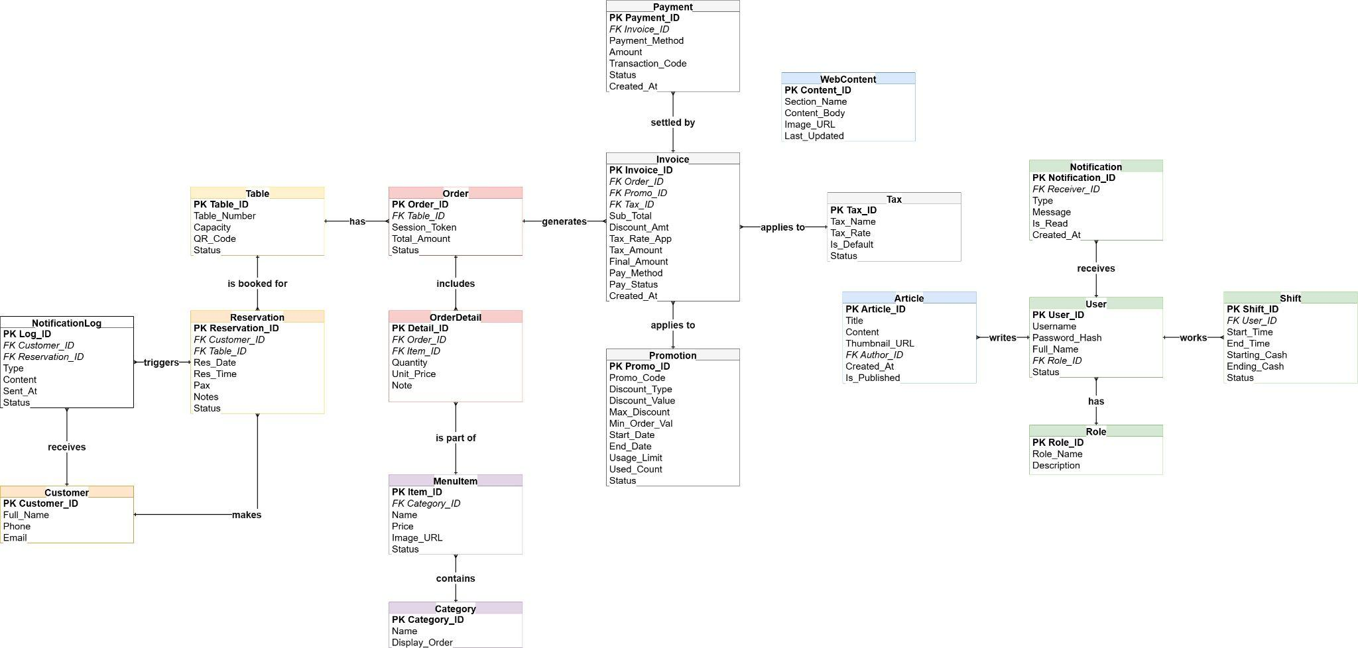

Entities Description

1. Content Management Module (Website CMS)
Used to manage content displayed on the Public Website (for customers to view).
Table Article (News / Posts)
Data Field | Data Type | Key | Detailed Description
Article_ID | INT | PK | Article ID.
Title | VARCHAR(255) |  | Article title.
Content | TEXT |  | Detailed article content (HTML format).
Thumbnail_URL | VARCHAR(255) |  | Cover image link.
Author_ID | INT | FK | ID of the employee who wrote the article (Linked to User table).
Created_At | DATETIME |  | Posting date and time.
Is_Published | BOOLEAN |  | Display status (True: Published, False: Draft).

Table WebContent (Static Page Configuration)
Data Field | Data Type | Key | Detailed Description
Content_ID | INT | PK | Content ID.
Section_Name | VARCHAR(50) |  | Content section name (e.g., ABOUT_US, HERO_BANNER).
Content_Body | TEXT |  | Text content.
Image_URL | VARCHAR(255) |  | Attached image (if any).
Last_Updated | DATETIME |  | Last updated time.

2. User & Staff Module
Manages access rights and cashier cash flows by shift.
Table Role
Data Field | Data Type | Key | Detailed Description
Role_ID | INT | PK | Role ID.
Role_Name | VARCHAR(50) |  | Role name (Admin, Manager, Waiter, Cashier).

Table User (Staff Accounts)
Data Field | Data Type | Key | Detailed Description
User_ID | INT | PK | Account ID.
Username | VARCHAR(50) |  | Login username.
Password_Hash | VARCHAR(255) |  | Encrypted password.
Full_Name | VARCHAR(100) |  | Staff full name.
Role_ID | INT | FK | Role ID (Linked to Role table).
Status | VARCHAR(20) |  | Status (Active, Inactive).

Table Shift (Cashier Working Shift)
Data Field | Data Type | Key | Detailed Description
Shift_ID | INT | PK | Shift ID.
User_ID | INT | FK | ID of the cashier on duty.
Start_Time | DATETIME |  | Shift opening time.
End_Time | DATETIME |  | Shift closing time.
Starting_Cash | DECIMAL |  | Initial cash amount (Petty cash for change).
Ending_Cash | DECIMAL |  | Actual cash amount when closing the shift.
Status | VARCHAR(20) |  | Status (Open, Closed).

3. Customer & Reservation Module
Handles online booking flows and status management.
Table Customer
Data Field | Data Type | Key | Detailed Description
Customer_ID | INT | PK | Customer ID.
Full_Name | VARCHAR(100) |  | Customer name.
Phone | VARCHAR(20) |  | Phone number (Used for SMS).
Email | VARCHAR(100) |  | Email for notifications.

Table Reservation (Booking Order)
Data Field | Data Type | Key | Detailed Description
Reservation_ID | INT | PK | Reservation ID.
Customer_ID | INT | FK | Linked to customer information.
Table_ID | INT | FK | Assigned table (Can be Null if not yet assigned).
Res_Date | DATE |  | Scheduled date.
Res_Time | TIME |  | Scheduled time.
Pax | INT |  | Number of guests.
Notes | TEXT |  | Notes (e.g., Baby chair, birthday...).
Status | VARCHAR(30) |  | BPMN flow status (Pending, Confirmed, Cancelled, Expired).

4. Table Management Module
Monitors real-time table statuses.
Table Table (Dining Table)
Data Field | Data Type | Key | Detailed Description
Table_ID | INT | PK | Table ID.
Table_Number | VARCHAR(20) |  | Table symbol (e.g., T01, VIP-2).
Capacity | INT |  | Maximum capacity (Number of people).
QR_Code | VARCHAR(255) |  | QR Code link/hash used for ordering at the table.
Status | VARCHAR(30) |  | Status (Available, Occupied, Billing, Cleaning).

5. Menu Management Module
Table Category (Menu Category)
Data Field | Data Type | Key | Detailed Description
Category_ID | INT | PK | Category ID.
Name | VARCHAR(100) |  | Category name (Main Course, Drinks...).
Display_Order | INT |  | Display order on the Menu.

Table MenuItem (Dish/Item)
Data Field | Data Type | Key | Detailed Description
Item_ID | INT | PK | Item ID.
Category_ID | INT | FK | Category containing this item.
Name | VARCHAR(150) |  | Item name.
Price | DECIMAL |  | Listed selling price (Excluding tax/promo).
Image_URL | VARCHAR(255) |  | Item image.
Status | VARCHAR(30) |  | Status (Available, Out_Of_Stock).

6. Ordering Module (QR Order & Kitchen)
Merges the "Cart" flow into the status of OrderDetail.
Table Order (Ordering Session)
Data Field | Data Type | Key | Detailed Description
Order_ID | INT | PK | Master order ID.
Table_ID | INT | FK | Table ID making the Order.
Session_Token | VARCHAR(255) |  | Anti-forgery token when scanning browser QR.
Total_Amount | DECIMAL |  | Temporary total amount.
Status | VARCHAR(30) |  | Order lifecycle (Ordering, Confirmed, Checkout_Requested, Closed).

Table OrderDetail (Items in Order/Cart)
Data Field | Data Type | Key | Detailed Description
Detail_ID | INT | PK | Detail ID.
Order_ID | INT | FK | Belongs to which Order.
Item_ID | INT | FK | Which item was ordered.
Quantity | INT |  | Quantity.
Unit_Price | DECIMAL |  | Price at the time of order (Prevents menu price changes from affecting the bill).
Note | VARCHAR(255) |  | Kitchen notes (e.g., Less spicy, No onions).

7. Payment, Promotion, & Tax Module (Payment, Promo, Tax)
Table Promotion (Discount Code)
Data Field | Data Type | Key | Detailed Description
Promo_ID | INT | PK | System ID.
Promo_Code | VARCHAR(50) |  | Input code (e.g., GRAND_OPENING).
Discount_Type | VARCHAR(20) |  | Classification (PERCENTAGE or FIXED_AMOUNT).
Discount_Value | DECIMAL |  | Value (e.g., Enter 20 for 20% off, 50000 for 50k off).
Max_Discount | DECIMAL |  | Maximum discount amount (For PERCENTAGE type).
Min_Order_Val | DECIMAL |  | Condition: Minimum invoice value.
Start_Date | DATETIME |  | Applicable start time.
End_Date | DATETIME |  | Code expiration time.
Usage_Limit | INT |  | Maximum number of uses for this code.
Used_Count | INT |  | Actual number of uses.
Status | VARCHAR(20) |  | (Active, Expired, Disabled).

Table Tax (Tax Configuration)
Data Field | Data Type | Key | Detailed Description
Tax_ID | INT | PK | System ID.
Tax_Name | VARCHAR(50) |  | Tax name (e.g., Standard VAT).
Tax_Rate | DECIMAL |  | Tax % (e.g., 8.0, 10.0).
Is_Default | BOOLEAN |  | Set as default tax applied to all bills (True).
Status | VARCHAR(20) |  | (Active, Inactive).

Table Invoice (Export Bill)
Data Field | Data Type | Key | Detailed Description
Invoice_ID | INT | PK | Export invoice ID (Bill printing ID).
Order_ID | INT | FK | Linked to which ordering session.
Promo_ID | INT | FK | Discount code used (If any).
Tax_ID | INT | FK | Tax line applied.
Sub_Total | DECIMAL |  | Original total amount (Sum from OrderDetail).
Discount_Amt | DECIMAL |  | Discounted amount (Calculated from Promo).
Tax_Rate_App | DECIMAL |  | Applied tax rate at that time (e.g., 8%). Saved for historical trace.
Tax_Amount | DECIMAL |  | Tax amount ( = (SubTotal - Discount) * TaxRate ).
Final_Amount | DECIMAL |  | TOTAL PAYMENT ( = SubTotal - Discount + Tax ).
Pay_Method | VARCHAR(30) |  | Method (Cash, VNPay, Momo, Card).
Pay_Status | VARCHAR(30) |  | Status (Pending, Success, Failed).
Created_At | DATETIME |  | Invoice export time.

8. System History Module (Notification Logs)
Table NotificationLog
Data Field | Data Type | Key | Detailed Description
Log_ID | INT | PK | History ID.
Customer_ID | INT | FK | Notification recipient.
Reservation_ID | INT | FK | Attached to which reservation.
Type | VARCHAR(20) |  | Sending channel (SMS, Email).
Content | TEXT |  | Sent message content.
Sent_At | DATETIME |  | Sending time.
Status | VARCHAR(20) |  | (Success, Failed).

Table Notification (Internal Staff Notice)
Data Field | Data Type | Key | Detailed Description
Notification_ID | INT | PK | Notification ID.
User_ID | INT | FK | Staff recipient.
Content | TEXT |  | Notification content.
Sent_At | DATETIME |  | Sending time.
Status | VARCHAR(20) |  | (Success, Failed).

2. Use Case Specifications

2.1 Authentication & User Management

2.1.1 Login (AM-01)
Primary Actors | Staff member (Waiter AC-02, Cashier AC-03, Kitchen Staff AC-04, Manager AC-05, System Administrator AC-06) | Secondary Actors | System (AC-07)
Description | As a staff member, I want to log in with my credentials so that I can access the POS functions permitted by my role.
Preconditions | - The user has an active account with an assigned role.  - The POS application is reachable.
Postconditions | - On success: A role-scoped session is established and the role-appropriate dashboard is shown.  - On failure: No session is created; the user remains on the login screen.
Normal  Sequence/Flow | 1. Actor: User opens the login screen and enters username and password.  System: System displays the login form.  2. Actor: User submits credentials.  System: System validates the credentials against stored records.  3. System: System creates a session, applies role-based permissions, and redirects to the role dashboard.
Alternative  Sequences/Flows | - E1 — Invalid credentials (Step 2): System rejects login, shows a generic error, and does not reveal which field was wrong.  - E2 — Account disabled/locked (Step 2): System denies access and advises contacting an administrator.  - E3 — Too many failed attempts: System temporarily locks the account per policy and logs the event.

2.1.2 Logout (AM-02)
Primary Actors | Authenticated staff member (AC-02→AC-06) | Secondary Actors | System (AC-07)
Description | As a staff member, I want to log out so that my session is securely terminated and no one can use it after I leave.
Preconditions | An active authenticated session exists.
Postconditions | The session/token is invalidated and the user is returned to the login screen.
Normal  Sequence/Flow | 1. Actor: User selects Logout.  System: System asks for confirmation if an action is in progress.  2. Actor: User confirms.  System: System invalidates the session and returns to the login screen.
Alternative  Sequences/Flows | - A1 — Auto-logout: After the configured inactivity timeout, the system ends the session automatically.  - E1 — Unsaved work (Step 1): System warns about unsaved changes and lets the user cancel logout.

2.1.3 Change Password (AM-03)
Primary Actors | Staff member (AC-02→AC-06) | Secondary Actors | System (AC-07); Notification Service (external) — for reset delivery.
Description | As a staff member, I want to change my current password so that I can keep my account secure.
Preconditions | The user is authenticated with an active session.  The user knows their current password.
Postconditions | On success: The new password is stored; the old password is no longer valid; other active sessions are optionally invalidated.  On failure: The password remains unchanged.
Normal  Sequence/Flow | 1. Actor: User opens Change Password and enters current password, new password, and confirmation.  System: System displays the change password form.  2. Actor: User submits the form.  System: System validates that the current password matches the stored credential.  3. Actor: User submits the new password.  System: System checks the new password against the strength policy.  4. System: System stores the new password and confirms the change. Optionally invalidates other active sessions.
Alternative  Sequences/Flows | - E1 — Wrong current password (Step 2): System rejects the change.  - E2 — New password fails policy (Step 3): System lists unmet requirements and prompts again.  - E3 — Expired/invalid reset token (Step 2): System rejects it and prompts the user to choose a different password.

2.1.4 Forgot Password (AM-04)
Primary Actors | Staff member (AC-02→AC-06) | Secondary Actors | System (AC-07); Notification Service (external) — delivers the reset link/code.
Description | As a staff member, I want to reset my forgotten password via a verified contact channel so that I can regain access to my account.
Preconditions | The user has an account with a verified email or phone number on record.  The user is not currently logged in.
Postconditions | On success: The password is reset to a new value chosen by the user; the reset token is invalidated; the user can log in with the new password.  On failure: The password remains unchanged; no valid token exists.
Normal  Sequence/Flow | 1. Actor: User opens Forgot Password and enters their registered email or phone number.  System: System displays the forgot password form.  2. Actor: User submits the request.  System: System verifies the email/phone exists in the system and sends a time-limited reset link/code via the Notification Service.  3. Actor: User opens the reset link/enters the code.  System: System validates the token is active and not expired.  4. Actor: User enters and confirms a new password.  System: System checks the new password against the strength policy.  5. System: System stores the new password, invalidates the token, and confirms. The user is redirected to Login (AM-01).
Alternative  Sequences/Flows | A1 — Resend code (Step 3): User requests a new code; System invalidates the previous token and issues a fresh one, subject to a rate limit.  - E1 — Email/phone not found (Step 2): System shows a generic message (does not confirm whether the account exists) and takes no action.  - E2 — Expired or invalid token (Step 3): System rejects the token and offers to resend; no password change occurs.  - E3 — New password fails strength policy (Step 4): System lists unmet requirements and returns the user to the form.  - E4 — Notification delivery fails (Step 2): System logs the failure and informs the user to try again; no token is committed until delivery is confirmed.

2.1.5 Manage User Accounts (UM-01)
Primary Actors | System Administrator (AC-06) | Secondary Actors | System (AC-07)
Description | As an administrator, I want to create, update, deactivate, or delete staff accounts so that only authorized people can access the system.
Preconditions | The administrator is authenticated with admin rights.
Postconditions | On success: The account record reflects the change and is logged (UM-03). On failure: No change.
Normal  Sequence/Flow | 1. Actor: Admin opens user management and chooses create/edit/deactivate/delete.  System: System displays the user list/form.  2. Actor: Admin enters or modifies account details and submits.  System: System validates uniqueness and required fields.  3. System: System saves the change, writes an audit entry, and confirms.
Alternative  Sequences/Flows | - A1 — Deactivate instead of delete: Admin disables an account to preserve history rather than deleting it.  - E1 — Duplicate username/email (Step 2): System blocks the save and flags the conflict.  - E2 — Deleting an account with history: System prevents hard delete and suggests deactivation.

2.1.6 Register (UM-02)
Primary Actors | System Administrator (AC-06) | Secondary Actors | (AC-07); Notification Service (external) — delivers login credentials to the new user.
Description | As an administrator, I want to register a new staff account so that the new user can log in and access system functions according to their assigned role.
Preconditions | The administrator is authenticated with admin rights.  The role to be assigned to the new user is already configured in the system.
Postconditions | On success: A new active staff account is created with an assigned role; the action is logged (UM-02 View Audit Log); login credentials are delivered to the new user.  On failure: No account is created.
Normal  Sequence/Flow | 1. Actor: Admin opens User Management and selects "Register New User".  System: System displays the registration form (full name, username, email/phone, role).  2. Actor: Admin fills in account details and assigns a role, then submits.  System: System validates required fields, checks that username and email are unique.  3. System: System creates the account with status "Active", assigns the role, and writes an audit entry.  4. System: System generates a temporary password and sends login credentials to the new user via the Notification Service, then confirms to the admin.
Alternative  Sequences/Flows | - A1 — Manual password set (Step 4): Admin manually sets the initial password instead of auto-generating; system still requires the user to change it on first login.  - E1 — Duplicate username or email (Step 2): System blocks the save, highlights the conflicting field, and prompts the admin to use a different value.  - E2 — Notification delivery fails (Step 4): Account is still created; system warns the admin that credentials could not be delivered and provides them on-screen for manual handover.

2.1.7 View Audit Log (UM-03)
Primary Actors | System Administrator (AC-06) / Manager (AC-05) | Secondary Actors | System (AC-07)
Description | As an administrator/manager, I want to view the log of important activities so that I can investigate incidents and meet the audit-logging requirement.
Preconditions | The user has permission to view the audit log; log entries exist.
Postconditions | The requested log entries are displayed; viewing does not alter them.
Normal  Sequence/Flow | 1. Actor: User opens the audit log and sets filters (date, user, action type).  System: System displays the filter controls.  2. Actor: User applies filters.  System: System retrieves and displays matching, read-only entries.
Alternative  Sequences/Flows | - A1 — Export log: User exports the filtered entries for offline review.  - E1 — No matching entries: System shows an empty-result message.

2.1.8 Export / Import System Data (UM-04)
Primary Actors | System Administrator (AC-06) | Secondary Actors | System (AC-07)
Description | As an administrator, I want to export or import core system data so that I can back up, migrate, or bulk-load records.
Preconditions | The user has admin rights; for import, a file in the supported format is provided.
Postconditions | On export: a data file is produced. On import success: valid records are added/updated and logged. On import failure: no partial corruption; errors reported.
Normal  Sequence/Flow | 1. Actor: Admin chooses Export or Import and selects the data scope/file.  System: System displays options/format requirements.  2. Actor: Admin confirms.  System: System (export) generates and provides the file; (import) validates the file.  3. System: (Import) System applies valid records, reports any rejected rows, and audits the operation.
Alternative  Sequences/Flows | - E1 — Invalid file format (Step 2): System rejects the import and explains the expected format.  - E2 — Partial validation failures (Step 3): System imports valid rows, lists rejected rows with reasons (or rolls back entirely, per configuration).

2.2 Reservation Management

2.2.1 Create Reservation (RM-01)
Primary Actors | Waiter (AC-02) | Secondary Actors | System (AC-07); Notification Service (external).
Description | As a waiter, I want to create a reservation on a guest's behalf (e.g., phone booking) so that a table is secured for them.
Preconditions | The waiter is authenticated; tables/capacity and operating hours are configured.
Postconditions | On success: A reservation is stored as "Confirmed", the slot/table is held, and a confirmation may be sent. On failure: No reservation created.
Normal  Sequence/Flow | 1. Actor: Waiter opens the reservation form and enters guest + booking details.  System: System displays the form.  2. Actor: Waiter submits.  System: System validates inputs and checks availability for the slot/party size.  3. System: System holds a suitable table, stores the reservation, and generates a reference.  4. System: System optionally sends a confirmation and shows the result.
Alternative  Sequences/Flows | - A1 — Slot unavailable (Step 2): System suggests alternatives; waiter adjusts and resubmits.  - E1 — Invalid/incomplete input (Step 2): System blocks the save and highlights fields.

2.2.2 Modify Reservation (RM-02)
Primary Actors | Waiter (AC-02) | Secondary Actors | System (AC-07); Notification Service (external).
Description | As a waiter, I want to edit an existing reservation's time, party size, or table so that I can accommodate guest changes.
Preconditions | A modifiable reservation exists (not past/cancelled/checked-in/no-show).
Postconditions | On success: Reservation reflects changes; holds adjusted; update notification optional. On failure: Original unchanged.
Normal  Sequence/Flow | 1. Actor: Waiter locates and opens the reservation.  System: System displays current details.  2. Actor: Waiter edits details and submits.  System: System validates inputs and re-checks availability if time/size changed.  3. System: System adjusts the hold, saves the update, and confirms.
Alternative  Sequences/Flows | - A1 — New slot unavailable (Step 2): System keeps the original and offers alternatives.  - E1 — Reservation not modifiable (Step 1): System blocks editing and explains why.

2.2.3 Cancel Reservation (RM-03)
Primary Actors | Waiter (AC-02) | Secondary Actors | System (AC-07); Notification Service (external).
Description | As a waiter, I want to cancel a reservation so that the held table is released and made available again.
Preconditions | A cancellable reservation exists.
Postconditions | On success: Reservation set "Cancelled"; table released (TM-03); cancellation notice optional. On failure: Unchanged.
Normal  Sequence/Flow | 1. Actor: Waiter locates the reservation and selects Cancel.  System: System asks for confirmation.  2. Actor: Waiter confirms.  System: System sets status Cancelled and releases the held table.  3. System: System confirms and optionally notifies the guest.
Alternative  Sequences/Flows | - E1 — Already cancelled/checked-in (Step 1): System reports the current status; no change.

2.2.4 Check-in Reservation (RM-04)
Primary Actors | Waiter (AC-02) | Secondary Actors | System (AC-07)
Description | As a waiter, I want to check in a guest who has a reservation so that the reserved table is marked occupied and an order session can begin.
Preconditions | The waiter is authenticated; a "Confirmed" reservation exists for the current period; the reserved (or equivalent) table is available.
Postconditions | On success: Reservation "Checked-in"; table "Occupied"; guest seated. On failure: States unchanged.
Normal  Sequence/Flow | 1. Actor: Waiter locates the reservation (name/phone/reference/calendar).  System: System displays the reservation and assigned table.  2. Actor: Waiter confirms arrival and selects Check-in.  System: System validates the reservation is Confirmed and not expired/cancelled.  3. System: System sets reservation Checked-in.  4. System: System (AC-07) sets the table Occupied (TM-03) and confirms seating.
Alternative  Sequences/Flows | - A1 — Assigned table unavailable (Step 2): Waiter selects an alternative free table; system reassigns and continues.  - A2 — Early/late arrival (Step 2): System warns if outside the tolerance window but allows override.  - E1 — Reservation not "Confirmed" (Step 2): System blocks check-in and shows current status.

2.2.5 View Reservation Calendar (RM-05)
Primary Actors | Waiter (AC-02) / Manager (AC-05) | Secondary Actors | System (AC-07)
Description | As a waiter/manager, I want to view reservations on a calendar/timeline so that I can plan seating and spot conflicts.
Preconditions | The user is authenticated; reservation data exists.
Postconditions | The calendar view is displayed; viewing does not change data.
Normal  Sequence/Flow | 1. Actor: User opens the reservation calendar and chooses a date range/view.  System: System displays the calendar controls.  2. Actor: User applies the view.  System: System renders reservations by time/table.
Alternative  Sequences/Flows | - A1 — Drill-in: User selects a reservation to see full details.  - E1 — No reservations in range: System shows an empty calendar with a message.

2.2.6 Monitor Reservations (Dashboard) (RM-06)
Primary Actors | Manager (AC-05) | Secondary Actors | System (AC-07)
Description | As a manager, I want a summary dashboard of reservation load and status so that I can monitor demand at a glance.
Preconditions | The manager is authenticated; reservation data exists.
Postconditions | Aggregated reservation metrics are displayed; read-only.
Normal  Sequence/Flow | 1. Actor: Manager opens the reservation dashboard.  System: System aggregates counts by status/time and renders summary widgets.  2. Actor: Manager adjusts filters (period, area).  System: System refreshes the aggregates.
Alternative  Sequences/Flows | - E1 — No data for period: System shows zeroed widgets with a message.

2.2.7 Seat Walk-in Guest (RM-07)
Primary Actors | Waiter (AC-02) | Secondary Actors | System (AC-07)
Description | As a waiter, I want to seat a guest with no reservation so that walk-ins can be served and an order session opened.
Preconditions | The waiter is authenticated; a free table of suitable capacity exists, or the guest accepts the waitlist.
Postconditions | On success: A free table is assigned and set "Occupied"; an order session opens. On failure: No assignment.
Normal  Sequence/Flow | 1. Actor: Waiter selects Seat Walk-in and enters party size.  System: System lists free tables matching the size.  2. Actor: Waiter selects a table.  System: System validates it is free and of sufficient capacity.  3. System: System sets the table Occupied (TM-03).  4. System: System opens a new order session and confirms seating.
Alternative  Sequences/Flows | - A1 — No suitable table (Step 1): System offers the waitlist (if enabled) or next availability.  - A2 — Combine tables (Step 2): Waiter selects multiple tables; system groups them under one order session.  - E1 — Table taken concurrently (Step 2/3): System rejects and refreshes availability.

2.2.8 Handle No-show (RM-08)
Primary Actors | Waiter (AC-02) | Secondary Actors | Manager (AC-05) — review/override; System (AC-07).
Description | As a waiter, I want to mark a reservation as a no-show so that the held table is released after the grace period elapses.
Preconditions | A "Confirmed" reservation exists whose time + grace period elapsed and that is not checked in.
Postconditions | On success: Reservation "No-show"; table released "Free". On failure: No change.
Normal  Sequence/Flow | 1. Actor: Waiter reviews overdue reservations.  System: System highlights eligible reservations.  2. Actor: Waiter selects one and chooses Mark No-show.  System: System confirms the grace period elapsed and not checked in.  3. System: System sets status No-show.  4. System: System (AC-07) releases the held table (TM-03).
Alternative  Sequences/Flows | - A1 — Guest arrives after marking: Waiter seats them via RM-07 subject to availability.  - E1 — Grace period not elapsed (Step 2): System blocks and shows remaining time.

2.3 Online Reservation

2.3.1 View Reservation Availability (ORM-01)
Primary Actors | Guest / Customer (AC-01) | Secondary Actors | System (AC-07)
Description | As a guest, I want to view available tables/time slots online so that I can choose a slot before booking. No login required.
Preconditions | The website is reachable; operating hours/capacity are configured.
Postconditions | Availability for the requested criteria is displayed; no booking is made.
Normal  Sequence/Flow | 1. Actor: Guest enters date, time, and party size.  System: System displays the availability search form.  2. Actor: Guest submits the query.  System: System computes and shows open slots/tables for the criteria.
Alternative  Sequences/Flows | - A1 — Proceed to book: Guest selects an open slot and continues to ORM-02 with details pre-filled.  - E1 — No availability: System shows nearest alternative slots.

2.3.2 Submit Online Reservation (ORM-02)
Primary Actors | Guest / Customer (AC-01) | Secondary Actors | System (AC-07); Notification Service (external).
Description | As a guest, I want to submit a reservation online so that I can secure a table for a chosen date, time, and party size without calling. No login required.
Preconditions | Website reachable; hours/capacity configured; guest on the reservation form.
Postconditions | On success: Reservation stored "Confirmed" (or "Pending" if approval needed); slot held; confirmation with reference sent. On failure: No reservation/hold; form retains input with a clear error.
Normal  Sequence/Flow | 1. Actor: Guest opens the reservation form.  System: System displays fields: date, time, party size, name, phone, email, note.  2. Actor: Guest enters details and submits.  System: System validates required fields and formats.  3. System: System checks table availability for the slot/party size.  4. System: System finds a suitable table and tentatively holds it.  5. System: System creates the reservation and generates a unique reference.  6. System: System triggers the confirmation and shows on-screen confirmation.
Alternative  Sequences/Flows | - A1 — Slot unavailable (Step 3/4): System offers nearest alternatives; guest adjusts and resubmits.  - A2 — Approval required (Step 5): Reservation saved "Pending"; guest told it will be confirmed shortly.  - A3 — Concurrent booking of held slot (Step 4/5): System aborts and returns to A1.  - E1 — Invalid/incomplete input (Step 2): System rejects, highlights fields, preserves input.  - E2 — Notification failure (Step 6): Reservation still saved; on-screen confirmation shown; delivery retried/logged.  - E3 — Persistence error (Step 5): System releases the hold, shows "try again later", logs, preserves input.

2.3.3 Cancel Reservation (Online) (ORM-03)
Primary Actors | Guest / Customer (AC-01) | Secondary Actors | System (AC-07); Notification Service (external).
Description | As a guest, I want to cancel my online reservation so that the table is released and I'm no longer expected.
Preconditions | A reservation exists, is identifiable by the guest, and is cancellable within the allowed window.
Postconditions | On success: Status "Cancelled"; table released; confirmation sent. On failure: Unchanged.
Normal  Sequence/Flow | 1. Actor: Guest opens their reservation and selects Cancel.  System: System displays it and asks for confirmation.  2. Actor: Guest confirms.  System: System validates it is cancellable within the window.  3. System: System sets Cancelled and releases the table (TM-03).  4. System: System sends a cancellation confirmation.
Alternative  Sequences/Flows | - E1 — Outside cancellation window (Step 2): System blocks and advises contacting the restaurant.  - E2 — Already cancelled/checked-in (Step 2): System reports status; no change.
2.4 Table Management

2.3.4 Modify Online Reservation (ORM-04)
Primary Actors | Guest / Customer (AC-01) | Secondary Actors | System (AC-07); Notification Service (external).
Description | As a guest, I want to change my online reservation's date, time, or party size so that I can adjust without cancelling and rebooking.
Preconditions | A reservation exists, is identifiable, modifiable, and within the modification window.
Postconditions | On success: Reservation reflects new details; hold adjusted; updated confirmation sent. On failure: Original unchanged.
Normal  Sequence/Flow | 1. Actor: Guest opens their reservation (reference + contact or secure link).  System: System displays current details.  2. Actor: Guest edits details and submits.  System: System validates new inputs.  3. System: System checks availability for the new slot/size.  4. System: System releases the old hold, holds the new slot, updates the reservation.  5. System: System sends an updated confirmation.
Alternative  Sequences/Flows | - A1 — New slot unavailable (Step 3): Original kept intact; alternatives offered.  - E1 — Outside modification window (Step 1/2): System blocks and advises contacting the restaurant.  - E2 — Not found / wrong credentials (Step 1): System denies access without revealing existence.

2.4.1 View Table Status (TM-01)
Primary Actors | Waiter (AC-02) | Secondary Actors | System (AC-07)
Description | As a waiter, I want to see real-time table occupancy so that I can manage seating and service.
Preconditions | The waiter is authenticated; tables are configured.
Postconditions | Current table statuses are displayed; read-only.
Normal  Sequence/Flow | 1. Actor: Waiter opens the floor/table view.  System: System renders each table with its live status.  2. Actor: Waiter selects a table (optional).  System: System shows that table's details (party, order, timing).
Alternative  Sequences/Flows | - A1 — Filter by area/status: Waiter filters to free or occupied tables.

2.4.2 Update Table Status (TM-02)
Primary Actors | Waiter (AC-02) | Secondary Actors | System (AC-07)
Description | As a waiter, I want to manually set a table's status so that I can correct or override the floor state (e.g., out-of-service).
Preconditions | The waiter is authenticated; the table exists.
Postconditions | On success: The table's status is updated and timestamped. On failure: Unchanged.
Normal  Sequence/Flow | 1. Actor: Waiter selects a table and chooses a new status.  System: System displays valid status options.  2. Actor: Waiter confirms.  System: System validates the transition and applies it.
Alternative  Sequences/Flows | - E1 — Invalid transition (Step 2): System blocks an inconsistent change (e.g., freeing a table with an open unpaid order) and explains.

2.4.3 Automatic Table Status Update (TM-03)
Primary Actors | System (AC-07) | Secondary Actors | Waiter / Cashier — originate triggering events.
Description | As the system, I automatically update a table's status in response to operational events so that staff always see accurate, real-time occupancy.
Preconditions | Tables and states are configured; a status-changing event occurs.
Postconditions | The affected table's status reflects the event; change timestamped and visible in real time.
Normal  Sequence/Flow | 1. Actor: Reservation checked-in / walk-in seated.  System: System sets the table Occupied.  2. Actor: Order closed and payment completed.  System: System sets the table Free (after cleanup, if configured).  3. Actor: Reservation confirmed for a future slot.  System: System marks the table Reserved for that window.  4. Actor: No-show released or reservation cancelled.  System: System returns the table to Free.
Alternative  Sequences/Flows | - A1 — Cleanup state (Step 2): With a turnover buffer, the table moves to "Cleaning" before "Free".  - E1 — Conflicting concurrent events: System applies in event order and logs conflicts for review.

2.4.4 Transfer / Merge Tables (TM-04)
Primary Actors | Waiter (AC-02) | Secondary Actors | System (AC-07)
Description | As a waiter, I want to move a party to another table or merge tables so that I can handle seating changes or large groups while keeping the order/bill intact.
Preconditions | Source table "Occupied" with an active order; destination free (transfer) or compatible (merge).
Postconditions | On success: Order session reassigned to the new/merged set; statuses updated. On failure: Unchanged.
Normal  Sequence/Flow | 1. Actor: Waiter selects an occupied table and chooses Transfer/Merge.  System: System displays eligible destination/partner tables.  2. Actor: Waiter selects the target table(s).  System: System validates compatibility/availability.  3. System: System reassigns the order session to the new/merged set.  4. System: System updates statuses (TM-03) and confirms.
Alternative  Sequences/Flows | - A1 — Merge bills (Step 3): On merge, system combines open orders into one bill (links to PM-08).  - E1 — Destination no longer free (Step 2/3): System aborts and refreshes the list.

2.5 Guest Ordering

2.5.1 View Digital Menu (GO-01)
Primary Actors | Guest / Customer (AC-01) | Secondary Actors | System (AC-07)
Description | As a guest, I want to browse the digital menu so that I can see dishes, prices, and details before ordering. No login required.
Preconditions | The guest accesses the menu (e.g., via table QR); the menu is published.
Postconditions | The menu is displayed; no order is created.
Normal  Sequence/Flow | 1. Actor: Guest opens the digital menu.  System: System loads categories and items with prices/availability.  2. Actor: Guest browses/searches and opens an item.  System: System shows item details (description, options, price).
Alternative  Sequences/Flows | - A1 — Filter/search: Guest filters by category or searches by name.  - E1 — Item unavailable: System marks the item as unavailable and disables ordering it.

2.5.2 Modify Order Items (GO-02)
Primary Actors | Guest / Customer (AC-01) | Secondary Actors | System (AC-07)
Description | As a guest, I want to add, remove, or adjust items in my cart so that the order matches what I want before submitting.
Preconditions | An active table session and an open cart exist.
Postconditions | The cart reflects the changes; no order is submitted yet.
Normal  Sequence/Flow | 1. Actor: Guest adds an item or opens the cart.  System: System updates the cart and running subtotal.  2. Actor: Guest changes quantities, options, or removes items.  System: System recalculates the cart.
Alternative  Sequences/Flows | - A1 — Special note: Guest adds a note/option to an item (if supported).  - E1 — Item becomes unavailable: System flags it and prompts removal/substitution.

2.5.3 Submit Order Request (GO-03)
Primary Actors | Guest / Customer (AC-01) | Secondary Actors | System (AC-07); Waiter (AC-02) — receives for confirmation (OM-02).
Description | As a guest, I want to submit my selected items so that my order reaches the restaurant and preparation can begin. Tied to the table session; no login.
Preconditions | Guest seated with an active session; menu loaded; cart non-empty.
Postconditions | On success: Order request recorded "Submitted/Pending confirmation" and visible in staff queues. On failure: No order; cart preserved.
Normal  Sequence/Flow | 1. Actor: Guest reviews the cart and selects Submit Order.  System: System validates the cart is non-empty and items available.  2. System: System records the request against the table session (Submitted).  3. System: System routes it to the waiter and acknowledges to the guest.  4. Actor: Guest tracks progress.  System: System exposes live status (GO-04).
Alternative  Sequences/Flows | - A1 — Item unavailable (Step 1): System flags/removes it and asks the guest to confirm the adjusted cart.  - A2 — Add to existing order (Step 2): New items appended as an additional round.  - E1 — Empty cart (Step 1): System blocks submission.  - E2 — Session expired/invalid (Step 1): System asks the guest to rescan the QR or call a waiter.

2.5.4 View Order Status (GO-04)
Primary Actors | Guest / Customer (AC-01) | Secondary Actors | System (AC-07)
Description | As a guest, I want to track my submitted order so that I know its progress (received, preparing, ready, served).
Preconditions | A submitted order exists for the guest's session.
Postconditions | Current order status is displayed; read-only.
Normal  Sequence/Flow | 1. Actor: Guest opens Order Status.  System: System displays each item's current stage.  2. System: System refreshes status as the kitchen updates it (OM-05).
Alternative  Sequences/Flows | - E1 — No active order: System shows that there is nothing to track.

2.5.5 Request Assistance (GO-05)
Primary Actors | Guest / Customer (AC-01) | Secondary Actors | System (AC-07); Waiter (AC-02) — recipient (OM-07).
Description | As a guest, I want to send a service request so that a waiter comes to my table without my having to flag one down.
Preconditions | An active table session exists.
Postconditions | A pending assistance request is recorded and surfaced to staff.
Normal  Sequence/Flow | 1. Actor: Guest selects Request Assistance.  System: System records the request with the table number.  2. System: System surfaces it to the waiter and acknowledges to the guest.
Alternative  Sequences/Flows | - A1 — Specify reason: Guest selects a reason (water, bill, help) included in the request.  - E1 — Duplicate request: System groups repeats from the same table.

2.6 Order Management

2.6.1 View Orders (OM-01)
Primary Actors | Waiter (AC-02) / Kitchen Staff (AC-04) | Secondary Actors | System (AC-07)
Description | As a waiter/kitchen staff, I want to view active orders and items so that I can manage service and preparation.
Preconditions | The user is authenticated; orders exist.
Postconditions | Active orders are displayed; read-only.
Normal  Sequence/Flow | 1. Actor: User opens the orders view.  System: System lists active orders by table/time with statuses.  2. Actor: User opens an order.  System: System shows the order's items and details.
Alternative  Sequences/Flows | - A1 — Filter by status/table: User filters the queue.

2.6.2 Update Order (OM-02)
Primary Actors | Waiter (AC-02) | Secondary Actors | System (AC-07); Kitchen Staff (AC-04) — receives confirmed items.
Description | As a waiter, I want to confirm and adjust a guest's order so that correct items are sent to the kitchen.
Preconditions | An active order session exists; a request (GO-03) or verbal order is pending.
Postconditions | On success: Order confirmed with correct items; items queued to the kitchen. On failure: Prior state retained.
Normal  Sequence/Flow | 1. Actor: Waiter opens the pending order.  System: System displays requested items and state.  2. Actor: Waiter adjusts items/notes and confirms.  System: System validates availability and pricing.  3. System: System sets items Confirmed and routes them to the kitchen queue.  4. System: System updates the order total and confirms.
Alternative  Sequences/Flows | - A1 — Add/remove dishes (Step 2): Waiter modifies via OM-03; recalculated and re-routed.  - E1 — Item unavailable at confirm (Step 2): System blocks the line and prompts substitution/removal.

2.6.3 Add / Remove Dishes (OM-03)
Primary Actors | Waiter (AC-02) | Secondary Actors | System (AC-07); Kitchen Staff (AC-04).
Description | As a waiter, I want to add or remove dishes on an existing order so that I can handle additional rounds or corrections.
Preconditions | An active (open) order exists.
Postconditions | On success: Order items and total updated; added items routed to the kitchen. On failure: Unchanged.
Normal  Sequence/Flow | 1. Actor: Waiter opens the order and adds/removes items.  System: System validates availability for additions.  2. Actor: Waiter confirms changes.  System: System updates the order, routes new items, and recalculates the total.
Alternative  Sequences/Flows | - A1 — Remove already-prepared item: System flags it (may require manager approval / affects billing).  - E1 — Item in preparation removal: System notifies the kitchen to stop.

2.6.4 Cancel Order (OM-04)
Primary Actors | Waiter (AC-02) | Secondary Actors | Manager (AC-05) — may authorize; System (AC-07); Kitchen Staff (AC-04).
Description | As a waiter, I want to cancel an order or specific items so that mistaken or withdrawn orders are not prepared or billed.
Preconditions | An active order/items exist.
Postconditions | On success: Order/items set "Cancelled"; kitchen notified; billing adjusted. On failure: Unchanged.
Normal  Sequence/Flow | 1. Actor: Waiter selects the order/items and chooses Cancel.  System: System asks for a reason/confirmation.  2. Actor: Waiter confirms (manager authorizes if required).  System: System validates permission.  3. System: System sets Cancelled, notifies the kitchen, and adjusts the total.
Alternative  Sequences/Flows | - A1 — Partial cancel: Only selected items are cancelled.  - E1 — Already prepared/served (Step 1): System requires manager authorization and notes billing impact.

2.6.5 Update Cooking Status (OM-05)
Primary Actors | Kitchen Staff (AC-04) | Secondary Actors | System (AC-07); Guest (AC-01) / Waiter (AC-02) — observe updates.
Description | As kitchen staff, I want to update item preparation status so that waiters and guests can track cooking progress in real time.
Preconditions | Confirmed items exist in the kitchen queue; staff authenticated or using the kitchen display.
Postconditions | Item/order status reflects the new stage; visible to waiter and guest.
Normal  Sequence/Flow | 1. Actor: Kitchen staff view the queue.  System: System lists confirmed items by table/time.  2. Actor: Staff mark an item Preparing.  System: System updates and timestamps the status.  3. Actor: Staff mark the item Ready.  System: System flags it ready and notifies the waiter (and GO-04).
Alternative  Sequences/Flows | - A1 — Partial readiness: Items in an order become ready at different times; each tracked independently.  - E1 — Item cancelled mid-prep: System flags the kitchen to stop (from OM-04).

2.6.6 Mark Order as Served (OM-06)
Primary Actors | Waiter (AC-02) | Secondary Actors | System (AC-07)
Description | As a waiter, I want to mark dishes as served so that the ordering workflow completes and the order is ready for billing.
Preconditions | Order items exist with status "Ready".
Postconditions | Served items/order set "Served"; order eligible for billing.
Normal  Sequence/Flow | 1. Actor: Waiter delivers ready items to the table.  System: System shows ready items for the table.  2. Actor: Waiter marks them Served.  System: System updates and timestamps the status.  3. System: System marks the order ready for billing and confirms.
Alternative  Sequences/Flows | - E1 — Item not yet ready (Step 2): System blocks marking "Served" for items still preparing.

2.6.7 Respond to Assistance Request (OM-07)
Primary Actors | Waiter (AC-02) | Secondary Actors | System (AC-07); Guest (AC-01) — originator.
Description | As a waiter, I want to receive and resolve guest assistance requests so that requests raised via the digital menu (GO-05) are actioned promptly.
Preconditions | A guest has raised an assistance request from a table session.
Postconditions | Request acknowledged and "Resolved"; the table's pending-assistance indicator cleared.
Normal  Sequence/Flow | 1. System: System surfaces the new request with table number.  2. Actor: Waiter acknowledges it.  System: System marks it In progress.  3. Actor: Waiter attends and resolves, then marks Resolved.  System: System clears the indicator and timestamps resolution.
Alternative  Sequences/Flows | - A1 — Reassign (Step 2): A busy waiter reassigns to another available waiter.  - E1 — Duplicate requests: System groups repeats from the same table.

2.7 Payment & Invoice Management
2.7.1 Generate Invoice (PM-01)
Primary Actors | Cashier (AC-03) | Secondary Actors | System (AC-07)
Description | As a cashier, I want to generate an invoice for an order so that the guest has an accurate bill. The system sums line items, applies any service charge and VAT, and subtracts discounts.
Preconditions | An order is in a billable state; VAT and any service-charge rate are configured.
Postconditions | On success: Invoice created (line items, subtotal, discount, service charge, VAT, total); order "Awaiting payment". On failure: No invoice.
Normal  Sequence/Flow | 1. Actor: Cashier selects the order/table to bill.  System: System retrieves confirmed/served items.  2. Actor: Cashier selects Generate Invoice.  System: System computes Subtotal = Σ(price × qty) − discount.  3. System: System computes service charge (if configured) and VAT on the appropriate base.  4. System: System produces the invoice with Total = Subtotal + Service charge + VAT and shows it.
Alternative  Sequences/Flows | - A1 — Apply discount/promotion (Step 2): Cashier applies a discount (PM-02); system recalculates.  - A2 — Split/merge first (Step 1): Cashier splits/merges (PM-08) before generating.  - E1 — No billable items (Step 1): System blocks generation and reports the order is not billable.

2.7.2 Apply Discount / Promotion (PM-02)
Primary Actors | Cashier (AC-03) | Secondary Actors | Manager (AC-05) — may authorize; System (AC-07).
Description | As a cashier, I want to apply an eligible discount or promotion to the bill so that the guest receives the correct reduced price.
Preconditions | An invoice/order exists; the discount/promotion is configured and eligible.
Postconditions | On success: Discount applied and total recalculated; recorded for reporting. On failure: No discount applied.
Normal  Sequence/Flow | 1. Actor: Cashier opens the bill and selects a discount/promotion (or enters a code).  System: System displays eligible options.  2. Actor: Cashier applies it (manager authorizes if required).  System: System validates eligibility and permission.  3. System: System recalculates the total and shows the applied discount.
Alternative  Sequences/Flows | - E1 — Ineligible/expired promotion (Step 2): System rejects it and explains why.  - E2 — Exceeds discount limit (Step 2): System requires manager authorization.

2.7.3 Process Payment (PM-03)
Primary Actors | Cashier (AC-03) | Secondary Actors | Payment Gateway (external); System (AC-07); Notification Service (external).
Description | As a cashier, I want to process the guest's payment against an invoice so that the transaction is recorded and the order can be closed.
Preconditions | An invoice "Awaiting payment" exists; a cashier shift is open (SM-01).
Postconditions | On success: Payment recorded; order closed (PM-04); table freed (TM-03); notification sent (NM-02). On failure: Invoice stays "Awaiting payment".
Normal  Sequence/Flow | 1. Actor: Cashier opens the invoice and selects a method (cash/card/e-wallet).  System: System shows the amount due and options.  2. Actor: Cashier enters tendered cash or initiates the electronic transaction.  System: System computes change (cash) or sends the request to the gateway.  3. System: System receives confirmation and marks the invoice Paid.  4. System: System closes the order (PM-04), frees the table (TM-03), triggers NM-02.
Alternative  Sequences/Flows | - A1 — Split payment (Step 1): Multiple methods/people; system records partials until balance is zero.  - A2 — Print/send invoice (post Step 3): Cashier prints/e-sends via PM-05.  - E1 — Gateway decline/timeout (Step 2/3): System reports failure; invoice stays unpaid; retry or change method.  - E2 — No open shift (Step 1): System blocks and prompts to open a shift (SM-01).

2.7.4 Close Order (PM-04)
Primary Actors | Cashier (AC-03) | Secondary Actors | System (AC-07)
Description | As a cashier, I want to close a fully paid order so that it is finalized and removed from active service.
Preconditions | The order's invoice is fully paid.
Postconditions | On success: Order set "Closed"; table released (TM-03). On failure: Order remains open.
Normal  Sequence/Flow | 1. Actor: Cashier selects Close Order on a paid invoice.  System: System verifies the balance is zero.  2. System: System sets the order Closed and releases the table.
Alternative  Sequences/Flows | - E1 — Outstanding balance (Step 1): System blocks closing until fully paid.

2.7.5 Print / Send Invoice (PM-05)
Primary Actors | Cashier (AC-03) | Secondary Actors | Printer Service (external); Notification Service (external); System (AC-07).
Description | As a cashier, I want to print or electronically send the invoice so that the guest receives a copy.
Preconditions | An invoice exists.
Postconditions | On success: Invoice printed or sent. On failure: No copy delivered; cashier informed.
Normal  Sequence/Flow | 1. Actor: Cashier selects Print or Send and (for send) enters/confirms the contact.  System: System prepares the invoice document.  2. Actor: Cashier confirms.  System: System sends it to the printer or via email/SMS and confirms.
Alternative  Sequences/Flows | - E1 — Printer offline (Step 2): System reports failure and offers electronic send.  - E2 — Send failure (Step 2): System logs and offers retry/alternate channel.

2.7.6 View Invoice Details (PM-06)
Primary Actors | Cashier (AC-03) / Manager (AC-05) | Secondary Actors | System (AC-07)
Description | As a cashier/manager, I want to view a specific invoice so that I can verify charges or answer guest questions.
Preconditions | The user is authenticated; the invoice exists.
Postconditions | Invoice details are displayed; read-only.
Normal  Sequence/Flow | 1. Actor: User searches/selects an invoice.  System: System retrieves it.  2. System: System displays line items, discounts, charges, VAT, total, and payment status.
Alternative  Sequences/Flows | - E1 — Invoice not found: System reports no matching invoice.

2.7.7 View Payment History (PM-07)
Primary Actors | Manager (AC-05) | Secondary Actors | System (AC-07)
Description | As a manager, I want to review historical payments so that I can monitor revenue and investigate transactions.
Preconditions | The manager is authenticated; payment records exist.
Postconditions | Matching payment records are displayed; read-only.
Normal  Sequence/Flow | 1. Actor: Manager opens payment history and sets filters (date, method, amount).  System: System displays filter controls.  2. Actor: Manager applies filters.  System: System retrieves and lists matching payments.
Alternative  Sequences/Flows | - A1 — Drill-in: Manager opens a record to see the linked invoice (PM-06).  - E1 — No matching records: System shows an empty result.

2.7.8 Split / Merge Bill (PM-08)
Primary Actors | Cashier (AC-03) | Secondary Actors | System (AC-07)
Description | As a cashier, I want to split one order into several checks or merge several into one so that guests can pay separately or together.
Preconditions | One or more billable orders exist for the table(s).
Postconditions | On success: Resulting check(s) have correctly recalculated subtotals, service charge, VAT, and totals. On failure: Structure unchanged.
Normal  Sequence/Flow | 1. Actor: Cashier selects an order and chooses Split/Merge.  System: System displays line items and target checks.  2. Actor: Cashier allocates items (split) or selects checks to combine (merge).  System: System validates each item is assigned exactly once.  3. System: System recalculates totals for each resulting check.  4. System: System produces the resulting invoice(s) ready for payment.
Alternative  Sequences/Flows | - A1 — Even split (Step 2): Cashier splits the total evenly by headcount.  - E1 — Unallocated/duplicated items (Step 2): System blocks completion until allocation is exact.

2.7.09 Reopen Closed Order (PM-09)
Primary Actors | Cashier (AC-03) / Manager (AC-05) | Secondary Actors | System (AC-07)
Description | As a cashier/manager, I want to reopen a closed/paid order so that I can correct items or payment after closing, with an audit trail.
Preconditions | A closed order exists; the actor has permission.
Postconditions | On success: Order reopened to an editable/billable state; action audited. On failure: Order stays closed.
Normal  Sequence/Flow | 1. Actor: User locates the closed order and selects Reopen.  System: System requires a reason and checks permission.  2. Actor: User confirms (manager authorizes if required).  System: System validates authorization.  3. System: System reopens the order, audits it, and makes corrections possible (links to PM-09 if refund needed).
Alternative  Sequences/Flows | - E1 — Authorization denied (Step 2): System blocks reopening.  - E2 — Period locked (Step 1): If the accounting period is closed, system blocks and advises an adjustment instead.

2.7.10 Manage Promotions / Discounts (PM-11)
Primary Actors | Manager (AC-05) | Secondary Actors | System (AC-07)
Description | As a manager, I want to create and configure promotions/discounts so that cashiers can apply them (PM-02) consistently.
Preconditions | The manager is authenticated.
Postconditions | On success: Promotion/discount rules saved with validity/eligibility; available to cashiers. On failure: No change.
Normal  Sequence/Flow | 1. Actor: Manager opens promotions and chooses create/edit/deactivate.  System: System displays the promotion list/form.  2. Actor: Manager defines type, value, eligibility, and validity period, then saves.  System: System validates the rules for conflicts/consistency.  3. System: System stores the promotion and confirms availability.
Alternative  Sequences/Flows | - A1 — Schedule promotion: Manager sets a future start/end; system activates it automatically in range.  - E1 — Conflicting/invalid rule (Step 2): System blocks the save and flags the conflict.

2.8 Shift Management

2.8.1 Open Shift (SM-01)
Primary Actors | Cashier (AC-03) | Secondary Actors | System (AC-07)
Description | As a cashier, I want to open a shift with an opening cash balance so that payments and cash movements are tracked against my shift.
Preconditions | The cashier is authenticated and has no other open shift on the same register.
Postconditions | On success: A shift is open with the recorded opening balance; payments can be processed. On failure: No shift opened.
Normal  Sequence/Flow | 1. Actor: Cashier selects Open Shift and enters the opening cash balance.  System: System validates no conflicting open shift exists.  2. Actor: Cashier confirms.  System: System creates the shift Open and timestamps it.
Alternative  Sequences/Flows | - E1 — Existing open shift (Step 1): System blocks and prompts to close the existing one first.

2.8.2 Record Cash In / Out (SM-02)
Primary Actors | Cashier (AC-03) | Secondary Actors | System (AC-07)
Description | As a cashier, I want to record cash added to or removed from the drawer so that the shift's expected cash stays accurate.
Preconditions | An open shift exists.
Postconditions | On success: The cash movement is recorded and the expected balance updated. On failure: No change.
Normal  Sequence/Flow | 1. Actor: Cashier selects Cash In or Cash Out and enters amount + reason.  System: System displays the entry form.  2. Actor: Cashier confirms.  System: System records the movement and updates expected cash.
Alternative  Sequences/Flows | - E1 — Cash out exceeds drawer (Step 2): System warns/blocks per policy.

2.8.3 Close Shift (SM-03)
Primary Actors | Cashier (AC-03) | Secondary Actors | Manager (AC-05) — may review; System (AC-07).
Description | As a cashier, I want to close my shift and reconcile cash so that totals are finalized and any discrepancy is recorded.
Preconditions | An open shift exists; no payment is mid-transaction.
Postconditions | On success: Shift "Closed"; expected vs. counted reconciled; summary available (SM-04). On failure: Shift remains open.
Normal  Sequence/Flow | 1. Actor: Cashier selects Close Shift.  System: System computes expected cash (opening + cash sales ± cash in/out).  2. Actor: Cashier enters the counted cash.  System: System compares counted vs. expected and computes variance.  3. Actor: Cashier confirms closing.  System: System sets Closed, stores the summary, and timestamps it.
Alternative  Sequences/Flows | - A1 — Variance present (Step 2): System records the discrepancy; may require a note/manager acknowledgement.  - E1 — Pending transaction (Step 1): System blocks closing until it completes or is cancelled.

2.8.4 View Shift Summary (SM-04)
Primary Actors | Cashier (AC-03) / Manager (AC-05) | Secondary Actors | System (AC-07)
Description | As a cashier/manager, I want to view a shift summary so that I can review sales, cash movements, and variance for a shift.
Preconditions | The user is authenticated; shift records exist.
Postconditions | The shift summary is displayed; read-only.
Normal  Sequence/Flow | 1. Actor: User selects a shift (current or past).  System: System retrieves the shift record.  2. System: System displays opening/closing balances, sales by method, cash movements, and variance.
Alternative  Sequences/Flows | - E1 — No shift selected/found: System prompts to select a valid shift.

2.9 Menu Management

2.9.1 Create / Update Menu Item (MM-01)
Primary Actors | Manager (AC-05) | Secondary Actors | System (AC-07)
Description | As a manager, I want to create or edit menu items so that the digital menu reflects current dishes, prices, and availability.
Preconditions | The manager is authenticated; categories exist.
Postconditions | On success: The item is saved and reflected in the menu. On failure: No change.
Normal  Sequence/Flow | 1. Actor: Manager opens menu management and chooses create/edit.  System: System displays the item form.  2. Actor: Manager enters name, category, price, description, availability, and saves.  System: System validates required fields and price format.  3. System: System stores the item and updates the published menu.
Alternative  Sequences/Flows | - A1 — Toggle availability: Manager marks an item unavailable ("86") without deleting it.  - E1 — Invalid/missing fields (Step 2): System blocks the save and highlights errors.

2.9.2 Manage Categories (MM-02)
Primary Actors | Manager (AC-05) | Secondary Actors | System (AC-07)
Description | As a manager, I want to create and organize menu categories so that items are grouped logically for guests.
Preconditions | The manager is authenticated.
Postconditions | On success: Category structure updated and reflected in the menu. On failure: No change.
Normal  Sequence/Flow | 1. Actor: Manager opens category management and chooses create/edit/reorder/delete.  System: System displays the category list.  2. Actor: Manager makes changes and saves.  System: System validates (e.g., name uniqueness).  3. System: System applies the changes to the menu.
Alternative  Sequences/Flows | - E1 — Delete category with items (Step 2): System blocks deletion or requires reassigning items first.

2.9.3 Search / Filter Menu Items (MM-03)
Primary Actors | Manager (AC-05) | Secondary Actors | System (AC-07)
Description | As a manager, I want to search and filter the menu catalog so that I can quickly find items to review or edit.
Preconditions | The manager is authenticated; menu items exist.
Postconditions | Matching items are displayed; read-only.
Normal  Sequence/Flow | 1. Actor: Manager enters a search term and/or selects filters (category, availability).  System: System displays search/filter controls.  2. Actor: Manager applies them.  System: System retrieves and lists matching items.
Alternative  Sequences/Flows | - E1 — No matches: System shows an empty result with a suggestion to broaden criteria.

2.9.4 Import / Export Menu Data (MM-04)
Primary Actors | Manager (AC-05) | Secondary Actors | System (AC-07)
Description | As a manager, I want to bulk import or export menu data so that I can update many items at once or back up the menu.
Preconditions | The manager is authenticated; for import, a supported-format file is provided.
Postconditions | On export: a menu file is produced. On import success: valid items added/updated and logged. On import failure: errors reported without corruption.
Normal  Sequence/Flow | 1. Actor: Manager chooses Import or Export and selects the file/scope.  System: System displays options/format requirements.  2. Actor: Manager confirms.  System: System (export) generates the file; (import) validates it.  3. System: (Import) System applies valid items and reports rejected rows.
Alternative  Sequences/Flows | - E1 — Invalid format (Step 2): System rejects the import and explains the expected format.  - E2 — Partial failures (Step 3): System imports valid rows and lists rejects with reasons.

2.10 Report & Analytics

2.10.1 View Financial Reports (RA-01)
Primary Actors | Manager (AC-05) | Secondary Actors | System (AC-07)
Description | As a manager, I want to view financial reports so that I can monitor revenue and financial performance.
Preconditions | The manager is authenticated; sales/payment data exist.
Postconditions | The requested report is displayed; read-only.
Normal  Sequence/Flow | 1. Actor: Manager selects a report and a period/filters.  System: System displays report parameters.  2. Actor: Manager runs the report.  System: System aggregates data and renders the report (totals, trends, breakdowns).
Alternative  Sequences/Flows | - A1 — Export: Manager exports the report for offline use.  - E1 — No data for period: System shows an empty report with a message.

2.10.2 View Guest Traffic Analysis (RA-02)
Primary Actors | Manager (AC-05) | Secondary Actors | System (AC-07)
Description | As a manager, I want to analyze guest traffic and reservation trends so that I can plan staffing and capacity.
Preconditions | The manager is authenticated; reservation/seating data exist.
Postconditions | The analysis is displayed; read-only.
Normal  Sequence/Flow | 1. Actor: Manager selects a period and grouping (hour/day/week).  System: System displays parameters.  2. Actor: Manager runs the analysis.  System: System aggregates traffic and renders trends/peaks.
Alternative  Sequences/Flows | - E1 — No data for period: System shows an empty analysis.

2.10.3 View Menu Performance Report (RA-03)
Primary Actors | Manager (AC-05) | Secondary Actors | System (AC-07)
Description | As a manager, I want to review best/worst-performing menu items so that I can optimize the menu.
Preconditions | The manager is authenticated; order data exist.
Postconditions | The report is displayed; read-only.
Normal  Sequence/Flow | 1. Actor: Manager selects a period and metric (quantity/revenue).  System: System displays parameters.  2. Actor: Manager runs the report.  System: System ranks items by the chosen metric and renders the result.
Alternative  Sequences/Flows | - A1 — Drill by category: Manager filters performance by category.  - E1 — No data for period: System shows an empty report.

2.11 Notification Management

2.11.1 Send Reservation Notification (NM-01)
Primary Actors | System (AC-07) | Secondary Actors | Notification Service (external); Guest (AC-01) — recipient.
Description | As the system, I automatically send reservation confirmations and reminders so that guests are informed without manual staff effort.
Preconditions | A reservation event occurred (created/confirmed/modified/cancelled) or a reminder is due; guest contact present; service configured.
Postconditions | On success: Notification dispatched and logged (NM-03). On failure: Failure logged and queued for retry.
Normal  Sequence/Flow | 1. Actor: Reservation confirmed/modified/cancelled, or reminder time reached.  System: System selects the template and recipient.  2. System: System dispatches via the Notification Service (email/SMS).  3. System: System records the dispatch and outcome in the log.
Alternative  Sequences/Flows | - A1 — Reminder schedule (Step 1): A scheduled reminder triggers without a state change.  - E1 — Delivery failure (Step 2): System logs and retries per policy; reservation unaffected.  - E2 — Missing contact info (Step 1): System skips dispatch, logs the reason, and flags staff if applicable.

2.11.2 Send Payment Notification (NM-02)
Primary Actors | System (AC-07) | Secondary Actors | Notification Service (external); Guest (AC-01) — recipient.
Description | As the system, I automatically send a payment confirmation after a successful payment so that the guest has a record of the transaction.
Preconditions | A payment completed successfully (PM-03); guest contact present; service configured.
Postconditions | On success: Payment notification dispatched and logged. On failure: Failure logged and queued for retry.
Normal  Sequence/Flow | 1. Actor: Payment marked Paid (PM-03).  System: System selects the payment-confirmation template and recipient.  2. System: System dispatches via the Notification Service.  3. System: System records the dispatch and outcome in the log.
Alternative  Sequences/Flows | - E1 — Delivery failure (Step 2): System logs and retries; payment record unaffected.  - E2 — Missing contact info (Step 1): System skips dispatch and logs the reason.

2.11.3 Manage Notification Log (NM-03)
Primary Actors | Manager (AC-05) | Secondary Actors | System (AC-07)
Description | As a manager, I want to view and manage the notification history so that I can verify deliveries and troubleshoot failures.
Preconditions | The manager is authenticated; notification log entries exist.
Postconditions | Matching entries are displayed; management actions (e.g., resend) are recorded.
Normal  Sequence/Flow | 1. Actor: Manager opens the notification log and sets filters (type, status, date).  System: System displays filter controls.  2. Actor: Manager applies filters.  System: System lists matching entries with delivery status.  3. Actor: Manager optionally resends a failed notification.  System: System re-dispatches and records the new attempt.
Alternative  Sequences/Flows | - E1 — No matching entries: System shows an empty result.  - E2 — Resend fails (Step 3): System logs the new failure and informs the manager.

2.11.4 Send Manual Notification (NM-04)
Primary Actors | Manager (AC-05) | Secondary Actors | Notification Service (external); Guest(s) (AC-01) — recipients; System (AC-07).
Description | As a manager, I want to compose and send a notification manually so that I can reach guests for ad-hoc messages (e.g., closure, special event).
Preconditions | The manager is authenticated; recipient(s) and contact details are available.
Postconditions | On success: The message is dispatched and logged (NM-03). On failure: Failure logged; manager informed.
Normal  Sequence/Flow | 1. Actor: Manager composes the message and selects recipient(s)/channel.  System: System displays the compose form.  2. Actor: Manager reviews and sends.  System: System validates recipients and content.  3. System: System dispatches via the Notification Service and logs the outcome.
Alternative  Sequences/Flows | - A1 — Schedule send (Step 2): Manager schedules the message for a later time; system sends it then.  - E1 — No valid recipients (Step 2): System blocks sending.  - E2 — Delivery failure (Step 3): System logs and offers retry.

3. Functional Requirements(lâm)
[Provide descriptions about the system’s functions/screens. The functions/screens are grouped by the system features, and even sub-features if needed. For the screens, you need to provide the screen layouts (mock-up screens) and relevant specifications if needed]

3.1 Feature Name1 (lâm hội vật (Tấn Đẹp Zai mò))

3.1.1 SubFeature Name1.1

3.1.1.1 Screen/Function Name1
[Content #1: UI layout (Mockup screen prototype)]
[Content #2: brief descriptions of the screen/function, mapped to the relevant use cases]
[Content #3: provide further descriptions for the screen’s components/fields using table format below]
Field Name | Description
Field Name1 | Field description: data type min/max length or value, initial data, etc.
Field Name2 | …
Field Group-Name1
Field Name3 | …
Field Name4 | …
Field Group-Name2
… | …

3.1.1.2 Screen/Function Name2
…

3.1.2 SubFeature Name1.2
…

3.2 User Authentication

3.2.1 User Register
…

3.2.2 User Login
…

3.2.3 Password Reset
…

3.3 System Administration

3.3.1 Master Data

3.3.1.1 Setting List
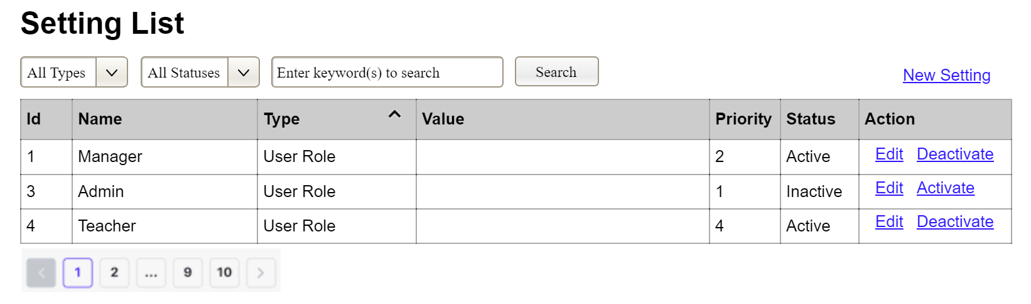
(1)
(2)
(3)
This screen allows the Administrator to:
- View Setting List: view list of current master data.
- Filter Setting List: filter master data by data types, statuses
- Search Settings: enter keyword(s) to search master data by their names or values
- Sort Setting List: sort master data list (ascending, descending) by clicking column headers
On the screen, s/he can also
- Activate/Deactivate Setting: change status of a specific inactive/active master data
- Choose to go to the Setting Details screens for adding new or updating an existing master data by clicking the New Setting or Edit link.
Field Description
Field Name | Description
(1) | Initial values: all the active setting names with null or blank type  Hover the mouse to show the field name: “Setting Type”
(2) | Initial values: All Statuses, Active, Inactive (default value “All Status”)  Hover the mouse to show the field name: “Setting Status”
(3) | The change-status action is Activate or Deactivate depending on the current status of the relevant setting (Inactive or Active, respectively).

3.3.1.2 Setting Details
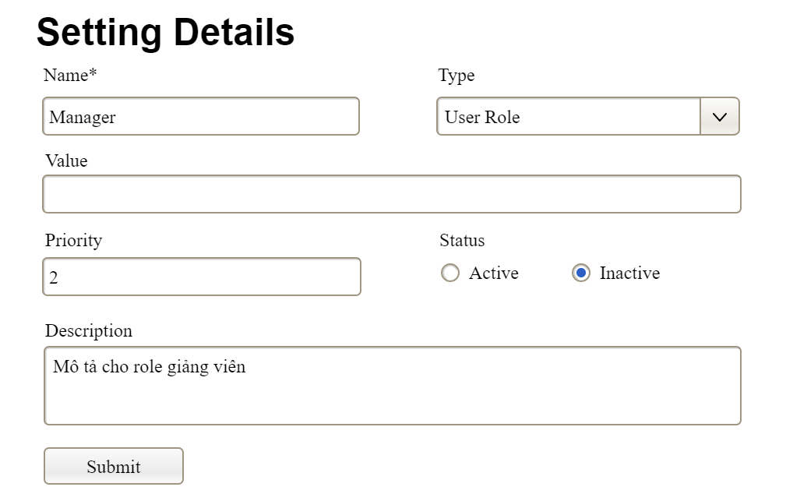

This screen allows the Administrator to:
- Add New Setting: add new master data.
- Update Setting Details: update details of a specific master data
Field Description
Field Name | Description
Name | Data type: non-digit string, max length of 20 characters
Type | Initial data values: all active setting names (with null or blank type)
Value | Data type: any string, max length of 100 characters
Priority | Data type: a positive integer
Description | Data type: any string, max length of 200 characters

3.3.2 User Management

3.3.2.1 User List
…

3.3.2.2 User Details
…

4. Non-Functional Requirements

4.1 External Interfaces
This section describes how the system communicates with users and with external hardware and software elements. The external integrations referenced here correspond to the Suggested External Integrations in the system context: Payment Gateway, Email/SMS Notification Service, Printer Service, QR Menu Service, and — for Vietnamese operation — the tax-authority e-invoice provider.

4.1.1 User Interfaces

● NFR-UI-01 The system provides two web front-ends: a public Online Reservation Website (Guest, AC-01) and an internal POS Web Application (staff AC-02→AC-06). Both are responsive and usable on desktop, tablet, and mobile browsers.

● NFR-UI-02 The guest-facing site requires no login for reservation (ORM-01/02/03/04) or digital ordering (GO-01→GO-05); guest sessions are tied to a reservation reference or a table QR code.

● NFR-UI-03 The UI presents only the functions permitted by the signed-in user's role (RBAC); unavailable actions are hidden or disabled rather than failing on use.

● NFR-UI-04 All screens display in a consistent layout, with input validation messages shown inline next to the offending field (e.g., Submit Online Reservation, ORM-02 E1).

4.1.2 Hardware Interfaces

● NFR-HW-01 Receipt/invoice printer — the system sends formatted invoices to a network or local thermal printer via the Printer Service (Print/Send Invoice, PM-05). On printer failure the system offers electronic delivery (PM-05 E1).

● NFR-HW-02 Payment terminal / card reader — where card payments are used, the POS interfaces with the terminal through the Payment Gateway (Process Payment, PM-03).

● NFR-HW-03 Kitchen display — Update Cooking Status (OM-05) supports a kitchen display/terminal that renders the live order queue.

● NFR-HW-04 QR code — table QR codes link guests to the digital menu and table session (GO-01); reservation/invoice QR codes are scannable for lookup.

4.1.3 Software Interfaces

● NFR-SW-01 Payment Gateway — Process Payment (PM-03) and Void/Refund Payment (PM-09) integrate with an external payment gateway over a secure API; gateway decline/timeout is handled gracefully (PM-03 E1).

● NFR-SW-02 Email/SMS Notification Service — all automated notifications (Send Reservation Notification NM-01, Send Payment Notification NM-02) and manual ones (NM-04) are dispatched via an external provider; failures are logged and retried (NM-01 E1).

● NFR-SW-03 E-invoice / tax-authority interface (Vietnam) — when deployed for a Vietnamese restaurant subject to the requirement, invoice data from the POS is transmitted to a licensed e-invoice provider connected to the tax authority (GDT), and the returned tax code/QR is attached to the customer copy (extends Generate Invoice PM-01 / Process Payment PM-03). (Confirm whether the live integration is in scope — see 4.2.8.)

● NFR-SW-04 QR Menu Service — the digital menu (GO-01) is served such that a QR scan opens the correct, current menu for the guest's table.

● NFR-SW-05 All external interfaces fail safe: an external service outage must not corrupt internal data (e.g., a reservation is still saved if notification delivery fails — ORM-02 E2).

4.1.4 Communication Interfaces

● NFR-CM-01 All client–server communication uses HTTPS/TLS.

● NFR-CM-02 Real-time updates (table status TM-01/TM-03, order/cooking status OM-05/GO-04, assistance requests GO-05/OM-07) are pushed to connected clients with low latency (see NFR-PE-04), e.g., via WebSocket or equivalent push mechanism, with graceful fallback to polling.

● NFR-CM-03 External API calls (payment, notification, e-invoice) use authenticated, encrypted channels with configurable timeouts and retry policies.

4.2 Quality Attributes

4.2.1 Usability

● NFR-US-01 A new staff user with basic POS familiarity can perform the core daily tasks — Seat Walk-in (RM-07), Update Order (OM-02), Generate Invoice (PM-01), Process Payment (PM-03) — productively after no more than 2 hours of guided training. (target — confirm)

● NFR-US-02 A guest with no prior exposure can complete Submit Online Reservation (ORM-02) or Submit Order Request (GO-03) without instructions, in under 3 minutes end to end. (target — confirm)

● NFR-US-03 Frequent POS actions (open order, add dish, send to kitchen, take payment) are reachable in 3 clicks/taps or fewer from the relevant dashboard.

● NFR-US-04 The UI conforms to common web GUI conventions and accessibility good practice (clear labels, sufficient contrast, keyboard navigability for POS forms).

● NFR-US-05 Error and validation messages are specific and actionable, and the system preserves user input when an action is rejected (e.g., ORM-02 E1).

● NFR-US-06 The interface supports the restaurant's working language(s); currency and date/time display follow the local locale (Vietnam: VND, dd/mm/yyyy). (confirm locale/multilingual scope)

4.2.2 Performance

Response time is measured from user action to system response under normal operating load, excluding external-service latency unless stated.

● NFR-PE-01 Data-viewing use cases — View Table Status (TM-01), View Digital Menu (GO-01), View Order Status (GO-04), View Invoice Details (PM-06) — respond in ≤ 2 s average, ≤ 4 s maximum. (target — confirm)

● NFR-PE-02 Transactional use cases — Submit Online Reservation (ORM-02), Update Order (OM-02), Generate Invoice (PM-01) — complete in ≤ 3 s average, ≤ 5 s maximum (excluding external gateway time). (target — confirm)

● NFR-PE-03 Process Payment (PM-03) completes the internal portion in ≤ 3 s; total time including the Payment Gateway depends on the gateway but the system shows progress and resolves within its configured timeout.

● NFR-PE-04 Real-time status changes (Automatic Table Status Update TM-03, Update Cooking Status OM-05, Request/Respond Assistance GO-05/OM-07) propagate to other connected clients within ≤ 2 s. (target — confirm)

● NFR-PE-05 Reports (View Financial Reports RA-01, Guest Traffic RA-02, Menu Performance RA-03) for a standard period render in ≤ 10 s; long periods may run asynchronously with a progress indicator. (target — confirm)

● NFR-PE-06 (Throughput) During peak service the system sustains ≥ 30 concurrent order/payment transactions without degrading beyond the limits above. (target — confirm to expected covers/hour)

● NFR-PE-07 (Capacity) The system supports the restaurant's full operating data set — e.g., ≥ 200 tables, ≥ 100 concurrent staff/guest sessions, and 2+ years of orders, reservations, invoices, and audit logs online — without redesign. (target — confirm to actual size)

● NFR-PE-08 (Resource utilization) Under the throughput in NFR-PE-06, server resource use (CPU, memory, DB connections) stays within provisioned headroom, leaving capacity for spikes. (define concrete thresholds during deployment sizing)

4.2.3 Security

● NFR-SE-01 Authentication (Login, AM-01) uses securely hashed credentials; passwords meet a configurable strength policy (Change/Reset Password, AM-03).

● NFR-SE-02 Role-Based Access Control governs every staff use case; the system enforces permissions server-side, not only by hiding UI (Assign Roles & Permissions, UM-02).

● NFR-SE-03 Sessions expire after a configurable inactivity period (Logout, AM-02 A1); sensitive actions (Void/Refund PM-09, Reopen Closed Order PM-10) require the appropriate permission and, where configured, manager authorization.

● NFR-SE-04 All traffic is encrypted in transit (TLS); sensitive data is protected at rest per applicable policy. Payment card data is handled by the gateway so the system avoids storing raw card data.

● NFR-SE-05 Audit logging records important actions — logins, payments, voids/refunds, reopens, role and menu/promotion changes, data import/export — with actor, timestamp, and outcome; the log is viewable (View Audit Log, UM-03) and tamper-resistant.

● NFR-SE-06 Guest-facing identifiers (reservation reference, table session) do not expose internal data; reservation lookup does not reveal whether a record exists to an unauthenticated party (ORM-04 E2).

● NFR-SE-07 Input is validated and sanitized on the server to prevent injection and similar attacks on all entry points (reservations, orders, payments).

4.2.4 Reliability & Availability

● NFR-RE-01 The system is available ≥ 99.5% during the restaurant's operating hours, the critical window for reservations, ordering, and payment. (target — confirm hours/SLA)

● NFR-RE-02 A failure in one external service (notification, printer, e-invoice) does not stop core operations; the dependent use case degrades gracefully and the failure is logged for retry/follow-up (e.g., ORM-02 E2, PM-05 E1, NM-01 E1).

● NFR-RE-03 Financial operations are consistent: a payment (PM-03) is either fully recorded or not at all; on persistence error any tentative state (e.g., a held table, ORM-02 E3) is released.

● NFR-RE-04 Concurrency is handled safely — concurrent seating/booking of the same table is detected and prevented (RM-07 E1, ORM-02 A3); conflicting status events are ordered and logged (TM-03 E1).

● NFR-RE-05 Data is backed up on a regular schedule with a defined recovery point and recovery time objective. (define RPO/RTO at deployment)

4.2.5 Scalability & Capacity

● NFR-SC-01 The architecture (separate front-ends and backend services per the suggested architecture) allows scaling the busiest services — Order, Payment, Notification — independently under load.

● NFR-SC-02 The system accommodates growth in tables, menu size, staff, and historical data (see NFR-PE-07) without functional redesign.

● NFR-SC-03 (If multi-branch is ever in scope) the data model should not preclude adding additional locations later. (confirm — single vs. multi-branch is currently undefined)

4.2.6 Maintainability

● NFR-MA-01 Configurable business values — VAT rate, service-charge rate, grace/modification/cancellation windows, auto-confirm threshold, discount limits, turnover buffer — are stored as settings, not hard-coded, so they can change without code changes (critical for VAT, which is scheduled to change — see 4.2.8).

● NFR-MA-02 Menu, promotions, roles, and notification templates are manageable by authorized users at runtime (MM-01/02, PM-11, UM-02, NM-04) without redeployment.

● NFR-MA-03 The system follows a modular design aligned to the functional modules, so a module can be modified or extended with minimal impact on others.

● NFR-MA-04 Logging and audit data support diagnosis of operational issues (UM-03, Manage Notification Log NM-03).

4.2.7 Compatibility & Portability

● NFR-CP-01 Both front-ends run on current versions of mainstream browsers (Chrome, Edge, Safari, Firefox) on desktop and mobile, with responsive layout.

● NFR-CP-02 No installation is required for guests or staff beyond a supported browser.

● NFR-CP-03 Exported/imported data (UM-04, MM-04) uses an open, documented format (e.g., CSV/Excel) for interoperability.

4.2.8 Compliance & Legal (Vietnam)

● NFR-CO-01 VAT is applied per the configured rate and shown explicitly on the invoice (Generate Invoice, PM-01). Because the rate is subject to legislative change (currently reduced, scheduled to revert), it must be configurable (NFR-MA-01) and effective-dated.

● NFR-CO-02 E-invoice obligation — for a restaurant required to issue e-invoices from the POS connected to the tax authority, the invoice must carry the prescribed fields (itemized items, unit price, quantity, price excl. VAT, VAT rate and amount, total, tax-authority code/QR) and be transmitted to the provider/GDT (extends PM-01/PM-03, via NFR-SW-03). (Confirm scope: full live integration vs. model-only for an academic deliverable.)

● NFR-CO-03 Record retention — invoices and related financial records are retained for the legally required period (10 years in Vietnam) and remain retrievable (PM-06, PM-07).

● NFR-CO-04 Personal data collected from guests (name, phone, email for reservations/notifications) is processed and protected in line with applicable data-protection rules, and used only for the stated purpose.

5. Requirement Appendix (Chi) - sau

5.1 Business Rules

ID | Rule Definition
BR-01 | Customers may only reserve tables with sufficient capacity for the specified party size.
BR-02 | Reservations must be made during the restaurant's operating hours.
BR-03 | A reservation must be made at least 30 minutes before the requested dining time.
BR-04 | A reservation is automatically marked as No-show if the customer does not check in within 15 minutes after the reserved time.
BR-05 | When a reservation is cancelled or marked as No-show, the associated table shall be released automatically.
BR-06 | Only menu items with status Available may be ordered by customers or staff.
BR-07 | A table may have only one active order session at any given time.
BR-08 | Table status shall be automatically updated based on reservation, seating, ordering, and payment activities.
BR-09 | Guests may modify or cancel reservations only within the allowed modification or cancellation period.
BR-10 | Orders submitted by guests must be confirmed by a waiter before being sent to the kitchen.

5.2 System Messages
Message code | System Message | Message code | System Message | Message code
MSG01 | Login successful. | MSG01 | Login successful. | MSG01
MSG02 | Invalid username or password. | MSG02 | Invalid username or password. | MSG02
MSG03 | Your account has been disabled. Please contact the administrator. | MSG03 | Your account has been disabled. Please contact the administrator. | MSG03
MSG04 | Reservation created successfully. | MSG04 | Reservation created successfully. | MSG04
MSG05 | Reservation updated successfully. | MSG05 | Reservation updated successfully. | MSG05
MSG06 | Reservation cancelled successfully. | MSG06 | Reservation cancelled successfully. | MSG06
MSG07 | The selected time slot is unavailable. Please choose another slot. | MSG07 | The selected time slot is unavailable. Please choose another slot. | MSG07
MSG08 | Guest check-in completed successfully. | MSG08 | Guest check-in completed successfully. | MSG08
MSG09 | Order submitted successfully. | MSG09 | Order submitted successfully. | MSG09
MSG10 | The selected item is currently unavailable. | MSG10 | The selected item is currently unavailable. | MSG10

5.3 Other Requirements…
OR-01 Data Retention
- Audit logs shall be retained for a minimum of 12 months.
- Transactional and financial records shall be retained for at least 5 years.
OR-02 Backup and Recovery
- The system shall perform automatic database backups daily.
- The maximum Recovery Time Objective (RTO) shall not exceed 4 hours.
OR-03 Security Requirements
- User passwords shall be stored using secure hashing algorithms.
- User accounts shall be temporarily locked after five consecutive failed login attempts.
- All sensitive data transmissions shall use HTTPS encryption.
OR-04 Notification Requirements
- The system shall send reservation confirmations and reminders via Email and/or SMS.
- The system shall notify customers when payments are successfully completed.
OR-05 Reporting Requirements
- Revenue and sales reports shall be generated in real time.
- Managers shall be able to export reports in PDF and Excel formats.

